A rare case of radiculopathy: Monostotic fibrous dysplasia of the sacrum
Um caso raro de radiculopatia: Displasia fibrosa monostótica do sacro

Authors: Joaquim C Teixeira, M.D.¹, Diogo C Simão, M.D.¹, José Pimentel, Ph.D.², Sérgio Livraghi, M.D.¹

Affiliations: ¹Department of Neurosurgery, Hospital de Santa Maria (CHLN), Lisbon, Portugal. ²Laboratory of Neuropathology, Department of Neurology, Hospital de Santa Maria (CHLN), Lisbon, Portugal.

Corresponding author: Joaquim Cruz Teixeira, M.D., Serviço de Neurocirurgia do Hospital de Santa Maria (CHLN), Avenida Professor Egas Moniz, 1649-035 Lisboa, Portugal
Phone: +351914826614
Fax: +351217805574
Email: joaquimcruzteixeira@hotmail.com

Título para cabeçalho: Displasia fibrosa do sacro

A rare case of radiculopathy: Monostotic fibrous dysplasia of the sacrum
Um caso raro de radiculopatia: Displasia fibrosa monostótica do sacro

Abstract
Fibrous dysplasia is a bone disease characterized by an osteoblastic dysfunction resulting in a fibrous replacement of the normal medullary bone. We describe the case of a 33-year-old female who presented with low back pain irradiating to her right leg. CT scan and MRI showed an osteolytic, multicystic lesion of the right hemissacrum with invasion of the right S1 foramen. She underwent foraminotomy and curettage of the lesion. Histological diagnosis was fibrous dysplasia, without features of malignant transformation. Three years after surgery the patient is asymptomatic and imaging is stable. This is the fifth known case of monostotic fibrous dysplasia involving the sacrum, a rare entity that must be considered in the differential diagnosis when approaching patients with sacral lesions.

Resumo
A displasia fibrosa é uma doença óssea caracterizada por uma disfunção osteoblástica que resulta na substituição do osso medular normal por tecido fibroso. Descrevemos o caso de uma doente de 33 anos que se apresentou com lombalgia e ciatalgia direita. A TC e RM lombares revelaram uma lesão osteolítica e multiquística no hemissacro direito com invasão do foramen de S1. A doente foi submetida a foraminotomia e curetagem da lesão. O diagnóstico histológico foi de displasia fibrosa, sem sinais de transformação maligna. Três anos após a cirurgia, a doente está assintomática e os estudos de imagem apresentam estabilidade da lesão. Este é o quinto caso conhecido na literatura de displasia fibrosa monostótica com atingimento do sacro, uma entidade rara que deve ser considerada no diagnóstico diferencial de doentes com lesões do sacro.

Key Words: Spine; Sacrum; Sacral tumor; Fibrous dysplasia; Monostotic; Sciatica

Introduction
Fibrous dysplasia is a genetic, non-inherited bone disease, characterized by an osteoblastic dysfunction resulting in a fibrous replacement of the normal medullary bone. It was first described by Lichtenstein in 1938⁽¹⁾ and it accounts for approximately 7% of all benign bone lesions⁽²⁾. This disorder is subdivided in monostotic and polyostotic forms, whether it affects one or multiple bones. Lesions are most commonly found in the long bones, ribs, clavicle and craniofacial bones⁽³⁾. Males and females are equally affected^{(4,5)}. Spinal involvement in fibrous dysplasia is extremely rare⁽⁶⁾, especially in the monostotic form. In this article, we present a case of monostotic fibrous dysplasia affecting the sacrum and a review of the literature.

Clinical Case
History: A thirty-three-year-old female presented to our Department referring intense low back pain and right sciatica. One month earlier she had been evaluated in another institution and underwent lumbar CT and lumbar MRI (Fig.1) that demonstrated an expansive osteolytic lesion of the right hemissacrum with cystic component and compression of the right S1 nerve root. A CT-guided biopsy was performed, the result was inconclusive and no diagnosis was established. She was then medicated with non-steroidal anti-inflammatory drugs and opioids. The symptoms increased gradually and one month after onset she presented to our Department for a second opinion. She had permanent low back pain without alleviating position and right S1 radiculopathy associated with hypoesthesia and paresthesia. No motor deficit was observed. The relevant medical history consisted of smoking habits. Laboratory studies showed normal blood cell count and normal C-reactive protein levels with no other remarkable changes. We proposed a surgical decompression of the right S1 nerve and biopsy of the lesion.

Operation: A right L5-S1 laminotomy, S1 foraminotomy and curettage of the lesion were performed with no complications.

Pathological Findings: Histology (Fig. 2 and Fig. 3) showed a dense fibrous tissue composed of spindle cells without cytologic anaplasia containing irregular trabeculae of metaplastic bone with scanty or no osteoblastic activity. The diagnosis of fibrous dysplasia was made.

Postoperative course: Patient was discharged on the day after surgery with mild S1 paresthesia, no radicular pain and improved low back pain. A scintigraphy study using ^{99m}Tc revealed no other bone involvement besides the right hemissacrum. At 3 years of follow-up the patient referred occasional mild low back pain that was successfully treated with non-steroidal anti-inflammatory drugs. She had no radicular pain or paresthesia. Control MRIs showed stability of the sacral lesion at this point. No further treatment was considered.

Discussion:
We found reference to four other patients with sacrum involvement of monostotic fibrous dysplasia. In Firat and Stutzman’s review, a single case of monostotic sacrum fibrous dysplasia was mentioned with no other clinical information added⁽⁷⁾. Schoenfeld et al described three patients with monostotic disease of the sacrum⁽⁸⁾. Two of these patients underwent curettage and bone-grafting. A 51 years-old female remained asymptomatic after 4 years and experienced reduction in the lesion dimension on plain radiograph. The other patient was a 32 years-old female who referred mild paresthesia in the left foot, but no change on imaging was elicited after 14 years. One other patient, a 22-year-old male that underwent biopsy and conservative treatment was asymptomatic and with no image change at 8 years of follow-up.
Fibrous dysplasia comprises 2,5% of all bone neoplasm and about 7% of all benign bone lesions⁽⁷⁾. The specific origin of fibrous dysplasia is not completely understood. It has been associated with an activating mutation of GNAS gene leading to an increase in cyclic adenosine monophosphate availability. This gene has also been linked to endocrine tumors and diseases⁽⁹⁾. Differential diagnosis includes bone tumors, Paget’s disease, hemangioma, aneurysmal bone cyst and giant cell tumor.
Monostotic form accounts for 70% to 85% of the patients while 15% to 30% have multiple bones affected (polyostotic form)⁽¹⁰⁾. Lesions are most commonly found in the femur, tibia, humerus, ribs, clavicle and craniofacial bones. Despite the higher frequency of the monostotic form, the axial skeleton is more often found in the polyostotic disease⁽¹¹⁾.
Bisphosphonates, primarily pamidronate, have been used most extensively for treating polyostotic disorder. Several studies have demonstrated their benefit in reducing clinical pain⁽¹²⁾. Other drugs like opioids and non-steroidal anti-inflammatory drugs are also used to control pain. New therapies like the monoclonal antibodies Denosumab (RANKL blocker) and Tanezumad (anti-NGF) are still being studied for this disease in clinical trials⁽¹³⁾. Surgery can be sometimes necessary for confirmatory biopsy, correction of deformity, prevention of pathologic fractures or nerve root decompression.

Malignant transformation is a rare condition, occurring in less than 1% of the cases, with only one case reported in the monostotic disease of the spine. The most common transformation is osteosarcoma, followed by fibrosarcoma and chondrosarcoma. It has been suggested that the probability of transformation to osteosarcoma increases after radiation treatment⁽¹⁴⁾.

We describe a case of monostotic fibrous dysplasia of the sacrum. According to our research, this is the fifth case reported in the English literature. Our approach had a double objective: treating a neurological symptom and attaining a histologic diagnosis. After the diagnosis, we ordered a bone scintigraphy to determine whether the disease was monostotic or polyostotic. If in the presence of polyostotic form, the patient would be referred to a multidisciplinary team.

Although rare, FD must be considered as a possible diagnosis when approaching lytic lesions of the sacrum. In the known reported cases of monostotic sacrum FD, a minimally aggressive treatment was sufficient to obtain symptom relieve when compared to aggressive treatments indicated to other sacral tumors. Despite its usual benign course, this disease requires a watchful waiting due to the possibility of lesion progression and/or malignant transformation.
References

1. Hertel F, Hopf T, Feiden W, Bettag M, Walter C, Delling G. Monostotic lumbar manifestation of fibrous dysplasia - a rare entity. Acta Neurochir (Wien). 2003 1;145:1021–2.
2. Gogia N, Marwaha V, Atri S, Gulati M, Gupta R. Fibrous dysplasia localized to spine: a diagnostic dilemma. Skeletal Radiol. 2007 36:19–23.
3. DiCaprio MR. Fibrous dysplasia pathophysiology, evaluation, and treatment. J Bone Jt Surg Am. 2005 1;87:1848.
4. Lichtenstein, L. Polyostotic fibrous dysplasia. Arch Surg. 1938;36:874–98.
5. Lichtenstein L, Jaffe HL. Fibrous dysplasia of bone: a condition affecting one, several or many bones, the graver cases of which may present abnormal pigmentation of skin, hyperthyroidism or still other extraskeletal abnormalities. Arch Pathol. 1942;33:777–816.
6. Ropper AE, Cahill KS, Hanna JW, McCarthy EF, Gokaslan ZL, Chi JH. Primary vertebral tumors: a review of epidemiologic, histological, and imaging findings, part I. Neurosurgery. 2011 69:1171–80.
7. Firat D, Stutzman L. Fibrous dysplasia of the bone. review of twenty-four cases. Am J Med. 1968 44:421–9.
8. Schoenfeld AJ, Koplin SA, Garcia R, Hornicek FJ, Mankin HJ, Raskin KA, et al. Monostotic fibrous dysplasia of the spine: a report of seven cases. J Bone Jt Surg-Am 2010 92:984–8.
9. DiCaprio MR, Enneking WF. Fibrous dysplasia. Pathophysiology, evaluation, and treatment. J Bone Joint Surg Am. 2005 87:1848–64.
10. Hoffman KL, Bergman AG, Kohler S. Polyostotic fibrous dysplasia with severe pathologic compression fracture of L2. Skeletal Radiol. 1995 24:160–2.
11. Ehara S, Kattapuram SV, Rosenberg AE. Fibrous dysplasia of the spine. Spine. 1992 17:977–9.
12. Morris CD. Bisphosphonates in orthopaedic surgery. J Bone Jt Surg Am. 2005 1;87:1609.
13. Chapurlat RD, Delmas PD, Liens D, Meunier PJ. Long-term effects of intravenous pamidronate in fibrous dysplasia of bone. J Bone Miner Res. 1997 1;12:1746–52.
14. Rodenberg J, Jensen OM, Keller J, Nielsen OS, Bünger C, Jurik AG. Fibrous dysplasia of the spine, costae and hemipelvis with sarcomatous transformation. Skeletal Radiol. 1996 25:682–4.

Figure Legend:
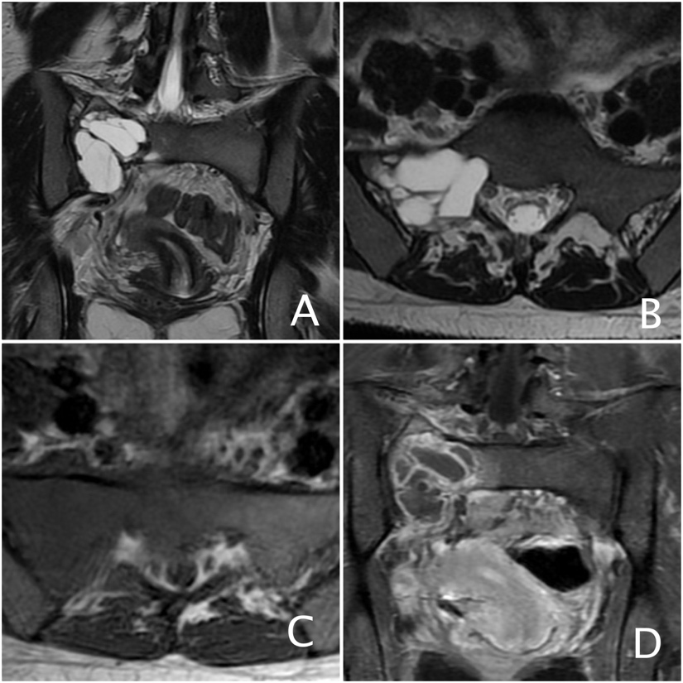

Figure 1. Expansive lesion of the right hemissacrum with associated cystic component and compression of the right S1 nerve root. A – Coronal T2 Weighted Image. B – Axial T2 Weighted Image. C – Axial T1 Weighted Image. D – Coronal T1 Weighted Image post gadolinium.

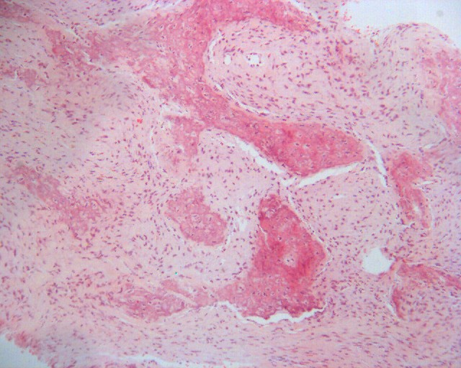

Figure 2. H.E.x10. Small magnification of the lesion displaying fibrous tissue and bone trabeculae.
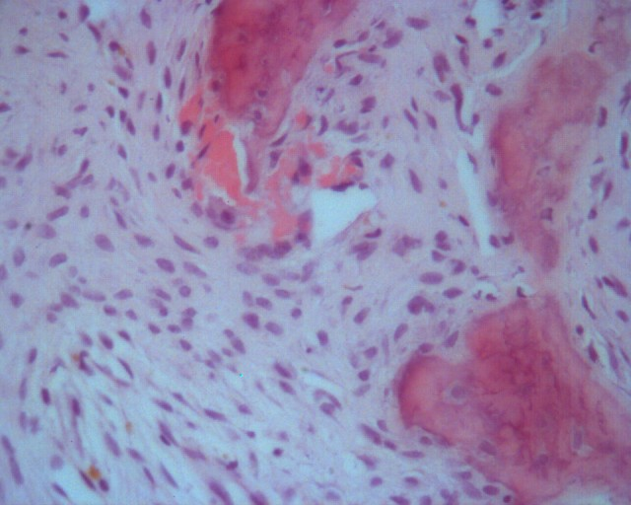

Figure 3. H.E.x40. Spindle cells with a whorled arrangement and trabeculae of immature woven bone devoid of osteoblasts

