Leishmaniose Visceral associada a Síndrome de Ativação Macrofágica e a Hemorragia Alveolar Difusa numa doente com Lupus

Visceral Leishmaniasis associated with Macrophage Activation Syndrome and Diffuse Alveolar Hemorrhage in a Lupus Patient

Andreia Costa¹, Cármen Pais¹, Sofia Cerqueira², Fernando Salvador³
1 Interna de Formação Específica de Medicina Interna, 2 Interna de Formação Específica de Nefrologia, 3 Assistente Hospitalar de Medicina Interna
Serviço de Medicina Interna, Centro Hospitalar de Trás-os-Montes e Alto Douro, Vila Real
Correspondência: Andreia Sofia Rocha Costa; andreia_inha2@hotmail.com; Mobile phone number +351 937451721; Internal Medicine Department, Centro Hospitalar de Trás-os-Montes e Alto Douro (CHTMAD) - Vila Real Hospital, Avenida da Noruega, 5000-508 Vila Real, Portugal

Protection of Humans and Animals: The authors declare that the procedures were followed according to the regulations established by the Clinical Research and Ethics Committee and to the Helsinki Declaration of the World Medical Association.
Data Confidentiality: The authors declare having followed the protocols in use at their working center regarding patients’ data publication.
Patient Consent: Obtained.
Conflicts of Interest: Authors report no conflict of interest.
Funding Sources: This research received no specific grant from any funding agency in the public, commercial, or not-for-profit sectors.

Título breve para cabeçalho
Systemic Lupus Erythematosus
Tipo de artigo: Caso Clínico
Leishmaniose Visceral associada a Síndrome de Ativação Macrofágica e a Hemorragia Alveolar Difusa numa doente com Lupus

Visceral Leishmaniasis associated with Macrophage Activation Syndrome and Diffuse Alveolar Hemorrhage in a Lupus Patient

Resumo
O Lupus Eritematoso Sistémico (LES) é uma doença autoimune heterogénea e imprevisível, o que pode complicar a sua abordagem e tratamento. A linfohistiocitose hemofagocítica (HLH) e a hemorragia alveolar difusa (HAD) são complicações raras da doença.
Os autores descrevem o caso de uma mulher de 32 anos, com Lupus e febre de origem indeterminada. Da investigação realizada, o mielograma revelou hemofagocitose e parasitas de Leishmania, pelo que iniciou anfotericina B lipossomal. Manteve febre apesar da terapêutica dirigida e evoluiu com HAD. Repetiu mielograma, mantendo hemofagocitose já sem parasitas, tendo aumentado corticoterapia e iniciado imunoglobulina com melhoria.
Dada a presença de síndrome de activação macrofágica e HAD iniciou rituximab.
Meses após a alta hospitalar, iniciou novamente febre sustentada e foram novamente identificados parasitas de Leishmania, pelo que reiniciou anfotericina B lipossomal associada a miltefosina.
Mantém follow-up, encontrando-se assintomática e com corticóides em esquema de desmame.
Palavras-chave: Lupus Eritematoso Sistémico; Síndrome de Activação Macrofágica; Leishmaniose Visceral; Hemorragia Alveolar Difusa
Abstract
Systemic Lupus Erythematosus (SLE) is a heterogeneous and unpredictable autoimmune disease which can be complicated to approach and treat. Hemophagocytic lymphohistiocytosis (HLH) and diffuse alveolar hemorrhage (DAH) are rare disease complications.
The authors describe a clinical case of a 32-year-old woman with Lupus and fever of unknown origin. From the investigations performed, the myelogram revealed hemophagocytosis and Leishmania parasites, therefore liposomal amphotericin B was then started. In addition to directed therapy, she maintained fever that evolved with DAH. The myelogram was repeated and showed that she still had hemophagocytosis but now without parasites. Corticotherapy was increased and intravenous Immunoglobulin was started, with improvement.
Rituximab was started as a result of Macrophage Activation Syndrome (MAS) and DAH.
Months after discharge, she began once again to have sustained fever and Leishmania parasites were found again, therefore liposomal amphotericin B was started once more associated with Miltefosine.
She continues being followed-up as she is asymptomatic and using steroids in weaning scheme.
Key Words: Systemic Lupus Erythematosus; Macrophage Activation Syndrome; Visceral Leishmaniasis; Diffuse Alveolar Hemorrhage

Introduction:
SLE is an autoimmune disease with a heterogeneous clinical course, characterized by periods of remission and relapse, with different degrees of severity that can affect any organ.¹ HLH and DAH can be complications of this disease.^{2,3}
This clinical case demonstrates the complexity of a patient with SLE who evolved with multiple and rare complications, including visceral leishmaniasis, MAS and DAH, and whose diagnostic and therapeutic approach was a constant challenge.

Clinical Case:
The authors describe a clinical case of a 32 years old woman with SLE since 2006, with cutaneous, articular and renal involvement, a SLICC/ACR damage index of 3 and a SLEDAI of 7. She is under treatment with 20 mg of prednisolone (PDN) in weaning scheme. She was in a regular Hemodialysis program as a result of lupus nephritis. She previously underwent several treatment regimens (cyclophosphamide, mycophenolate mofetil, cyclosporin and human intravenous immunoglobulin), always with disease progression.
She had previous multiple infectious, mostly central venous catheter (CVC) infections, in recent weeks, as well as lupus flares with fever and elevated inflammation markers, and was treated only with an increase dose of corticosteroids.
In early December 2015 she went to the Emergency Room with fever, which had been developing for four months, hematemesis and melena. Anemia was identified (Hb 5.88 g/dl) and transfusion support was performed. Upper endoscopy revealed a pylorus ulcer of 8 mm without active bleeding, associated with PDN and non-steroidal anti-inflammatory drug use.
Laboratory tests (see Table 1) showed pancytopenia, increased inflammatory parameters, normal coagulation parameters, normal haptoglobin and the peripheral blood smear did not show morphological changes. Ferritin was very high, 2309 ng/ml, and hypertriglyceridemia was 560 mg/dl.
Polymerase chain reaction for Mycobacterium tuberculosis, HBV, HCV and HIV was negative, as well as other requested serologies (Syphilis, Rubella, Paul Bunnell, CMV, Widal, Wright, Rose Bengal and Rickettsia).
Ds-DNA was elevated and complement was decreased.
Chest radiograph was normal and the abdominopelvic computerized tomography (CT) revealed a homogeneous splenomegaly. The transthoracic/transesophageal echocardiogram excluded an endocarditis.
On suspicion of CVC infection, she started ceftazidime and daptomycin and the CVC was removed a few days later. A new tunneled right femoral CVC was placed.
HLH was then suspected and a myelogram was performed. Hemophagocytosis (Fig. 1) and many Leishmania parasites (Fig. 2) were found. The Leishmania serology (IgG and IgM) was also positive.
She had also 41/mm3 NK lymphocytes (N: 90-590) and 165/mm3 CD4 (N: 410-1590).
HLH associated with Visceral Leishmaniasis (Kala-azar) was assumed, fulfilling the HLH 2004 criteria and with a HScore 2014 of 242 (99% probability) (see Table 2).
The epidemiological data were reviewed and contact with a dog with a possible leishmania infection was reported in June/July 2015.
She started liposomal amphotericin B (4 mg/kg on days 1-5, 10, 17, 24, 31 and 38 - total dose of 40 mg/ kg).
After 2 weeks she maintained fever, pancytopenia, hyperferritinemia, hypertriglyceridemia as well as elevated inflammatory parameters (see Table 1). She maintained high ds-DNA and complement consumption. The chest CT scan showed new bilateral pulmonary infiltrates in ground glass and the bronchoscopy with bronchoalveolar lavage revealed macrophages with hemosiderin inclusions, Golden Score 315. Microbiology was negative.
Bone marrow examination was repeated showing hemophagocytosis, without parasites. Simultaneously, she deteriorated with prostration, respiratory failure and hypotension requiring aminergic support and noninvasive ventilation. Klebsiella pneumoniae carbapenemase-producing bacteria were then isolated in blood cultures and in the hemodialysis catheter. This catheter was removed and antibiotic therapy with meropenem and colistin was initiated. Prednisolone dose was increased to 2 mg/kg/day (previously with 30 mg) and intravenous human immunoglobulin 400 mg/kg/day for 5 days was started due to DAH and MAS (HLH associated with rheumatic diseases), in the meantime she was diagnosed with a concomitant infection.
During this period, a skin injury was identified on the external face of the left leg. Infectious panniculitis was assumed and the biopsy was compatible (Fig. 3).
She evolved with sustained apyrexia, reduction of inflammatory parameters and persistently negative cultures.
Afterwards she underwent rituximab 375 mg/m² treatment for 4 weeks.
She became asymptomatic, with clinical and laboratory improvement and maintained B-cell depletion, with steroids in a weaning scheme (prednisolone nearly 5mg/day). DsDNA progressively reduced and complement levels increased to almost normal values.
Despite initial improvement, seven months after discharge she began to maintain fever once again. She was readmitted, with pancytopenia, hyperferritinemia and homogeneous splenomegaly.
The bone marrow was reexamined and Leishmania parasites were found again. Once again, we started liposomal amphotericin B and Miltefosine 50mg bid 28 days.
She evolved well with sustained apyrexia, and resolution of the pancytopenia. We decided to continue liposomal amphotericin B (3mg/Kg) every three weeks until resolution of immunosuppression.

Discussion:
HLH is an aggressive and potentially fatal disease.^{2,4,5} A febrile syndrome of unknown origin with multi organ involvement should alert us to this possibility. In this case, the combination of fever with pancytopenia, hyperferritinemia, hypertriglyceridemia and splenomegaly raised this suspicion. Hemophagocytosis was also found on bone marrow examination.
Non-response to directed treatment was verified, the study was continued and culminated in the diagnosis of another rare but life-threatening complication of SLE, with a high early mortality rate: DAH. Taking into account laboratory markers of lupus activity and HLH, a MAS was simultaneously assumed.
Specific therapy is based on agressive immunossupressive treatment. Due to a severe clinical situation and concomitant infection, it was decided to initiate intravenous immunoglobulin and then rituximab.
Despite the fact that data is limited on rituximab and intravenous immunoglobulin, there are some case reports that show its benefits in SLE, particularly in severe and refractory disease. There is also some evidence of rituximab in preventing recurrences of DAH in patients with Lupus.^{3,6,7,8}
Due to reactivation of Leishmania infection, despite scant information in the literature, we have decided to maintain prophylaxis with liposomal amphotericin B while the patient is B cell depleted, similar to what is recommended for HIV infection.^{9,10,11,12,13}
This case underline the complexity and difficulty of diagnosis. It was a constant challenge taking into account the rare and life-threatening complications of SLE, like HLH (associated with Leishmaniasis or autoimmune disease) and DAH. The association of infectious complications made clinical reasoning and targeted treatment more difficult.

Bibliography:
- Cervera R., Espinosa G., Ramos-Casals M., Hernández-Rodríguez J., Cid M. C. Enfermedades Autoinmunes Sistémicas, Diagnóstico y tratamiento, 5ª Edición, Madrid: Editorial Médica Panamericana, 2015, Page 1-27
- Rosado F.G.N., Kim A.S. Hemophagocytic lymphohistiocytosis: an update on diagnosis and pathogenesis. Am J Clin Pathol 2013; 139:713
- Pottier V., Pierrot M., Subra J.F., Mercat A., Kouatchet A., Parrot A. et al. Successful rituximab therapy in a lupus patient with diffuse alveolar haemorrhage. Lupus 2011; 20:656
- Kleynberg R., Schiller G., Secondary Hemophagocytic Lymphohistiocytosis in Adults: An Update on Diagnosis and Therapy, Clinical Advances in Hematology & Oncology Volume 10, Issue 11 November 2012, Page 726-732
- McClain K.L. Treatment and prognosis of hemophagocytic lymphohistiocytosis. Up to date [Acessed April 19, 2016] Available from: http://www.uptodate.com
- Tse J.R., Schwab K.E., McMahon M., Simon W. Rituximab: an emerging treatment for recurrent diffuse alveolar hemorrhage in systemic lupus erythematosus. Lupus 2015; 24:756-759
- Prior-Español A., Martínez-Morillo M., Riveros-Frutos A., Olivé A. Cartas al Editor. Tratamiento con rituximab e inmunoglobulinas en la hemorragia alveolar difusa recurrente en lupus eritematoso sistémico. Med Clin (Barc). 2015;145(11):507–509
- Martínez-Martínez M.U., Abud-Mendoza C. Recurrent diffuse alveolar haemorrhage in a patient with Systemic Lupus Erythematosus: long-term benefit of rituximab. Lupus 2012 21: 1124 originally published online 29 March 2012
- McQuarrie S., Kasper K., Moffatt D.C., Marko D., Keynan Y. Relapse of visceral leishmaniasis in an HIV-infected patient successfully treated with a combination of miltefosine and amphotericin B. Canadian Journal of Infectious Diseases and Medical Microbiology. 2015 Nov-Dec; 26(6): 325-329
- Lindoso J.A.L., Cunha M.A., Queiroz I.T., Moreira C.H.V. Leishmaniasis – HIV coinfection: current challenges. HIV/AIDS – Research and Palliative Care, Volume 8, 2016, Pages 147-156
- Bern C. Clinical manifestations and diagnosis of visceral leishmaniasis. Up to date [Acessed April 19, 2016] Available from: http://www.uptodate.com
- Murray H.W. Treatment of visceral leishmaniasis in 2004. Am J Trop Med Hyg 2004; 71:787
- Rajagopala S., Dutta U., Chandra K.S., Bhatia P., Varma N., Kochhar R. Visceral leishmaniasis associated hemophagocytic lymphohistiocytosis--case report and systematic review. J Infect 2008; 56:381
- Fardet L., Galicier L., Lambotte O., Marzac C., Aumont C., Chahwan D. et al. Development and Validation of the HScore, a Score for the Diagnosis of Reactive Hemophagocytic Syndrome. ARTHRITIS & RHEUMATOLOGY. Vol. 66, No. 9, September 2014, pp 2613–2620. DOI 10.1002/art.38690

Figures
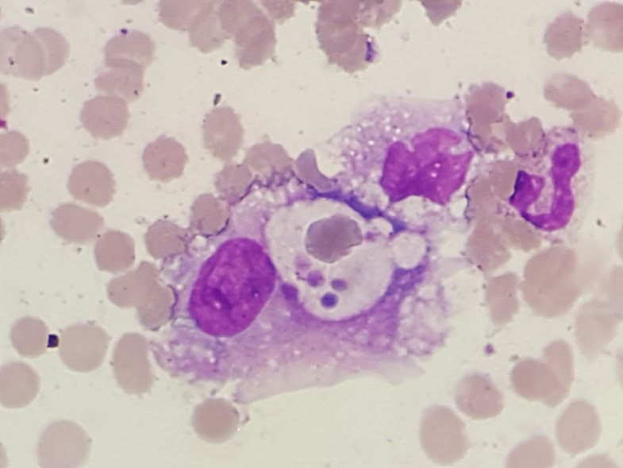
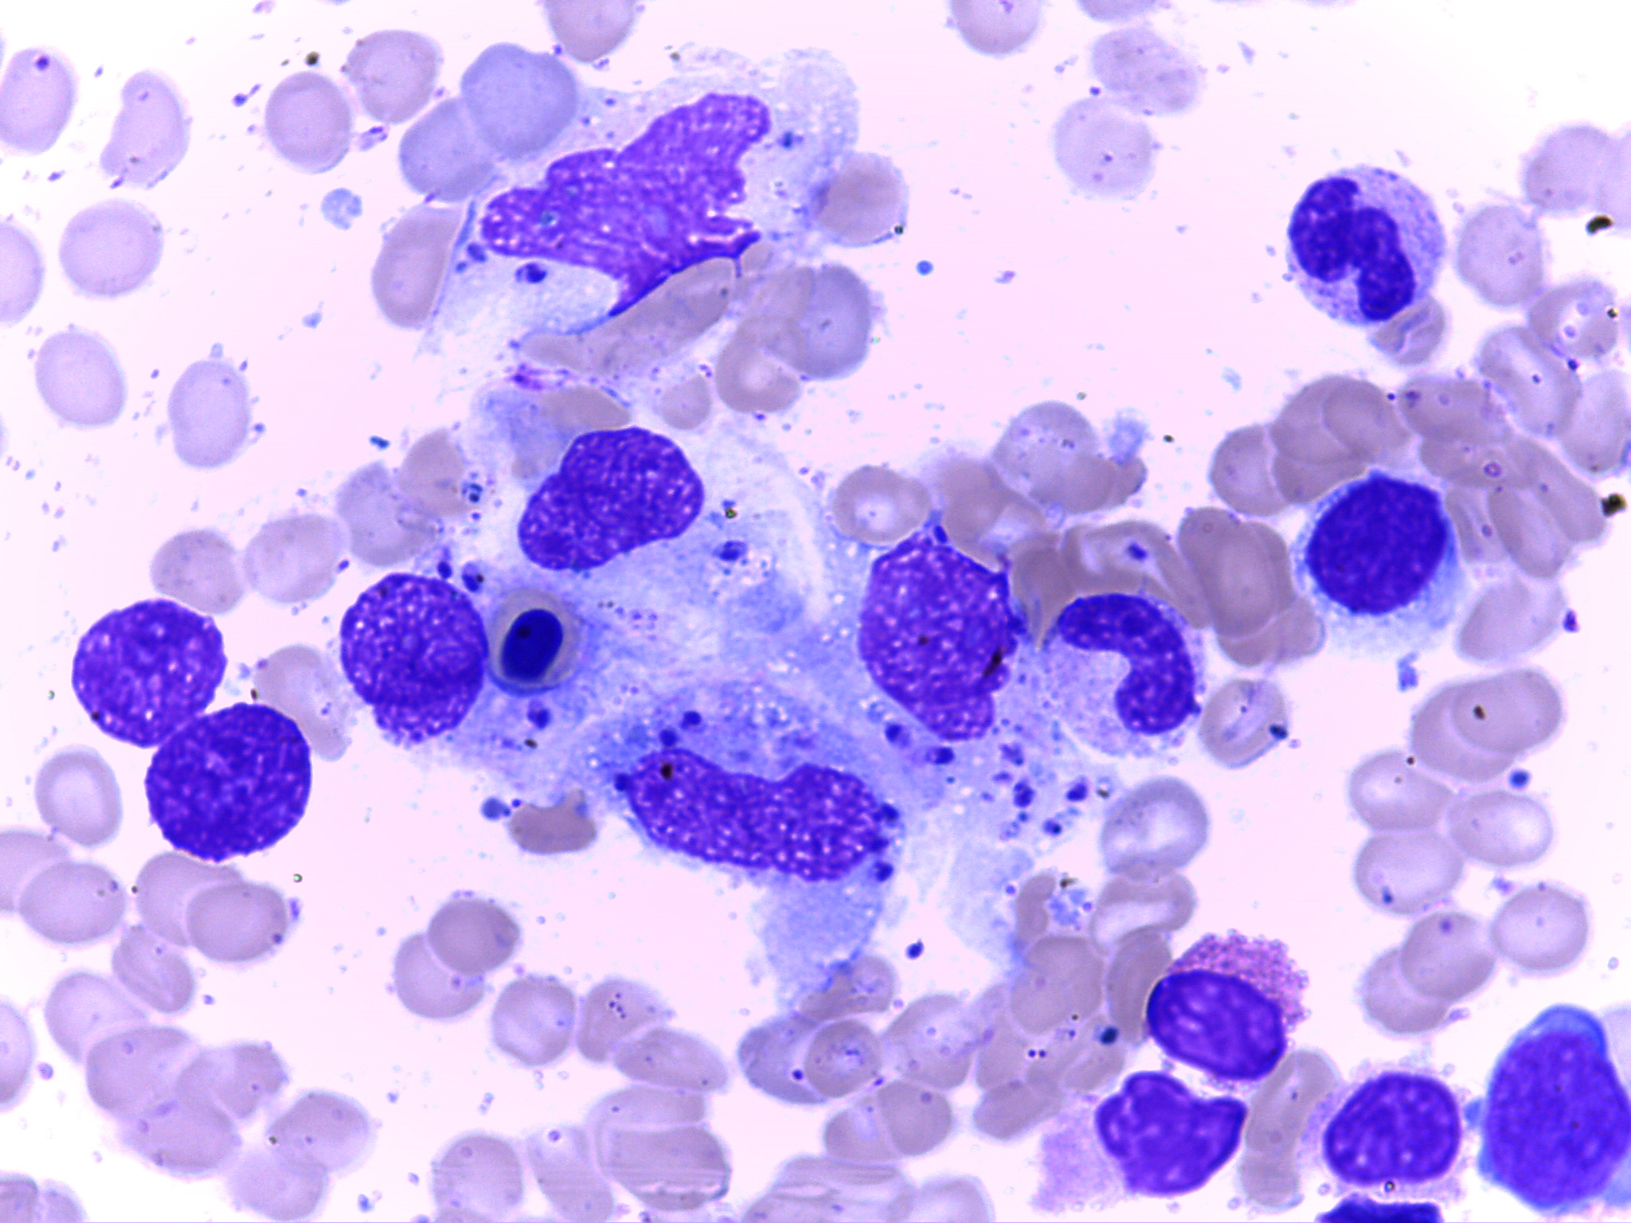

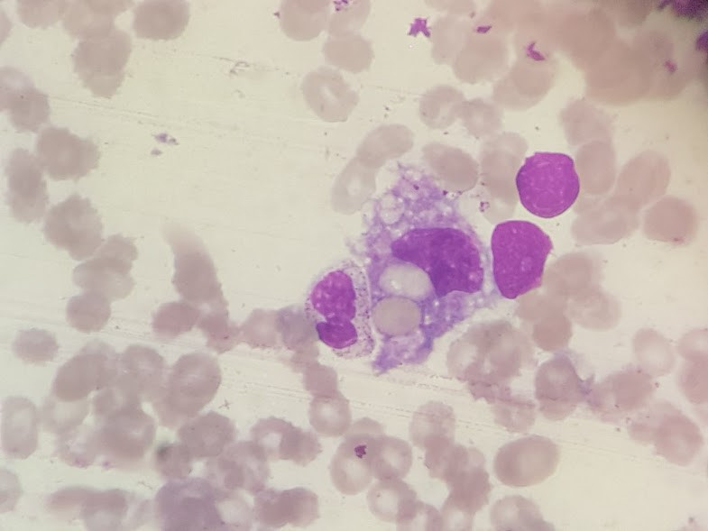

Figure 2. Leishmania amastigotes

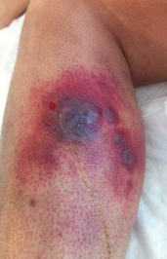
Figure 1. Hemophagocytosis

Figure 3. Infectious panniculitis
Table 1: Laboratory tests during hospitalization and in outpatient follow-up
 | To admission  (December 2015) | Diagnosis of HLH and leishmaniasis | Under amphotericin B | After 2 weeks of amphotericin B -  MAS + DAH + CVC infection | At hospital discharge (February 2016) | New hospitalization  (September 2016) -  Reactivation of visceral leishmaniasis | At hospital discharge (October 2016)
Hemoglobin (g/dl) (N: 12-16) | 5,88 |  | 10,23 | 7,5 | 10,89 | 9,7 | 8,7
Leukocytes (cel/uL) (N: 4-11) | 2600 |  | 3000 | 2600 | 6100 | 2200 | 3000
Platelet (cel/uL) (N: 150-400) | 66000 |  | 89000 | 85000 | 174000 | 101000 | 177000
C-reactive protein (mg/dl) (N: <0,5) | 7,2 |  | 1,9 | 34 | 1,6 | 2,2 | 1,6
Erythrocyte sedimentation rate (mm/h) (N: <10) | 40 |  |  | 110 |  | 15
Ferritin (ng/ml) (N: 10-291) | 2309 |  | 1411 | 1598 | 641 | 1869 | 615
Triglycerides (mg/dl) (N: <150) | 560 |  | 513 | 488 | 275 | 245 | 230
Antinuclear antibodies | 1:1280
Anti-dsDNA (UI/ml) (N: <10) | >379 |  |  | >379 | 77 | 75 | 60
Complement C3 / C4 (mg/dl) (N: 90-180 /12 -36) | 25 / 6 |  |  | 38 / <6 | 87 / 14 | 67 / 14 | 85 / 19
Antiphospholipid antibodies | Negative
Immunoglobulins (IgG, IgM, IgA, IgE) | Normal

Table 2: The HScore - Score for the Diagnosis of Reactive Hemophagocytic Syndrome – 2014¹⁴
Parameter | No of points (criteria for scoring)
Known underlying immunosuppression* | 0 (no) or 18 (yes)
Temperature (°C) | 0 (<38.4), 33 (38.4–39.4), or 49 (>39.4)
Organomegaly | 0 (no), 23 (hepatomegaly or splenomegaly), or 38 (hepatomegaly and splenomegaly)
No. of cytopenias† | 0 (1 lineage), 24 (2 lineages), or 34 (3 lineages)
Ferritin (ng/ml) | 0 (<2,000), 35 (2,000–6,000), or 50 (>6,000)
Triglyceride (mmoles/liter) | 0 (<1.5), 44 (1.5–4), or 64 (>4)
Fibrinogen (gm/liter) | 0 (>2.5) or 30 (≤2.5)
Serum glutamic oxaloacetic transaminase (IU/liter) | 0 (<30) or 19 (≥30)
Hemophagocytosis features on bone marrow aspirate | 0 (no) or 35 (yes)
* Human immunodeficiency virus positive or receiving long-term immunosuppressive therapy (i.e., glucocorticoids, cyclosporine, azathioprine).
† Defined as a hemoglobin level of ≤9.2 gm/dl and/or a leukocyte count of ≤5,000/mm3 and/or a platelet count of ≤110,000/mm3.

