Author Statements for Publication

A completed form must be hand-signed by all authors. When completed, scan and email to: depeditorial@actamedicaportuguesa.com

Manuscript ID 16783
Title
Iberoamerican authors in the scientific production on suicide in times of pandemics/ Autores ibero-americanos na produção científica sobre suicídio em tempos de pandemias

List of authors (keeping the order in which authors were presented in manuscript’s submission)
Miguel A. Saavedra-López

María Rojas-Pisfil
Lynton J. Sandoval-Navarro

Ronald M. Hernández
Xiomara M. Calle-Ramirez

Corresponding author
Miguel A. Saavedra-López

E-mail
saavedralopezmiguel@gmail.com

Address
Jirón Sánchez Carrión 225 Tumbes - Peru

I. Authorship contribution
By signing this document, authors are declaring:
- Their agreement with the proposed author as corresponding author;
- Their agreement with the proposed number and order of authors of the manuscript;
- Their significant contribution to the manuscript in compliance with the Recommendations for the Conduct, Reporting, Editing and Publication of Scholarly work in Medical Journals issued by the International Committee of Medical Journal Editors - ICMJE, namely (please specify each author’s contribution to the manuscript):

Date: 02 /07 /2021

Authorship contribution
Miguel A. Saavedra-López

Name:
Contribution:
Conception of the idea.
Drafting, review and approval of the article.

María Rojas-Pisfil

Name:
Contribution:
Drafting, review and approval of the article.
Review of the data.

Lynton J. Sandoval-Navarro
Name:
Contribution:
Drafting, review and approval of the article.
Review of the data.

Name:
Ronald M. Hernández
Contribution:
Review and approval of the article.
Realization of the data.

Xiomara M. Calle-Ramirez
Name:
Contribution:
Review and approval of the article.
Realization of the data.

II. Authorisation to publish
By signing this document, authors are declaring:
- Their agreement that the manuscript will be held jointly by Acta Médica Portuguesa and the authors, in case the manuscript is accepted for publication by Acta Médica Portuguesa, and cannot be reproduced, in whole or in part, without previous consent by the editors. These restrictions do not apply to abstracts whether or not presented in scientific meetings.
- Their agreement with the manuscript being made available electronically as well as in paper by Acta Médica Portuguesa, according to the Creative Commons Attribution License – NonCommercial – NoDerivatives (Notice: this means that authors’ copyright is maintained, as well as any electronic copy, distribution and printing of published manuscripts for non-commercial, academic or individual purposes is allowed, without any permission or payment, provided that the authorship and source are referred; in addition, derivative works licensing is required in similar terms).

Date: 02/07/2021

Author’s signatures:
Miguel A. Saavedra-López

Name:
Master in Public Management
Professional degree:
Signature:
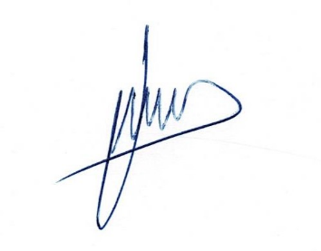

María Rojas-Pisfil

Name:
Student of psychology
Professional degree:
Signature:

Lynton J. Sandoval-Navarro
Name:
Student of psychology

Professional degree:
Signature:

Ronald M. Hernández
Name:
Professional degree:
Master in Education
Signature:
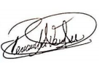

Xiomara M. Calle-Ramirez

Name:
Master in Psychology
Professional degree:
Signature:

