Title (EN): Tackling medication non-adherence in Portugal: the boost of the ENABLE COST action
Título (PT): Melhorar a adesão à medicação em Portugal: o impulso da ação COST ENABLE

Maria Teresa Herdeiro, Assistant Professor, Institute of Biomedicine (iBiMED), Medical Sciences Department, University of Aveiro, Aveiro, Portugal
Fátima Roque, Adjunct Professor, Research Unit for Inland Development, Polytechnic of Guarda (UDI-IPG), Guarda, Portugal
Cristina Jácome, Assistant Researcher, Center for Health Technology and Services Research (CINTESIS), Faculty of Medicine, University of Porto, Porto, Portugal; and Department of Community Medicine, Information and Health Decision Sciences (MEDCIDS), Faculty of Medicine, University of Porto, Porto, Portugal.
Tiago Maricoto, Aveiro Healthcare Centre, Aradas Health Unit, Aveiro, Portugal; Faculty of Health Sciences, GRUBI – Systematic Reviews Group, University of Beira Interior, Covilhã, Portugal, University of Beira Interior, 6200-506 Covilhã, Portugal
Pedro M Teixeira, Assistant Professor, School of Medicine, Minho University. Life and Health Sciences Research Institute (ICVS), School of Medicine, University of Minho, Braga Portugal. ICVS/3B's, PT Government Associate Laboratory, Braga/Guimarães, Portugal
Paulo A.S. Moreira, North Lusíada University, Centro de Investigação em Psicologia para o Desenvolvimento [The Psychology for Positive Psychology Research Center] (CIPD), Porto, Portugal.
João Gregório, Assistant Researcher, CBIOS – Universidade Lusófona’s Research Center for Biosciences & Health Technologies, Lisboa, Portugal.
Jaime Correia de Sousa, Associate Professor, School of Medicine, Minho University. Life and Health Sciences Research Institute (ICVS), School of Medicine, University of Minho, Braga Portugal. ICVS/3B's, PT Government Associate Laboratory, Braga/Guimarães, Portugal

Funding:
João Gregório is funded by Foundation for Science and Technology (FCT) Scientific Employment Stimulus contract with the reference number CEEC/CBIOS/EPH/2018.
Corresponding author:
Maria Teresa Herdeiro
Departamento de Ciências Médicas
Campus Universitário de Santiago, Agra do Crasto,
Edifício 30, 3810-193 Aveiro
teresaherdeiro@ua.pt

Medication adherence is a crucial factor in the effectiveness and safety of medicines and is particularly critical for patients undergoing chronic treatments. Non-adherence is also a major concern among health systems worldwide. Around 50% of patients with a chronic disease do not adhere to their therapeutic regimen, making non-adherence a widespread health problem, with a significant impact on health systems¹. Only in Europe, non-adherence has shown to contribute to nearly 200,000 premature deaths, with costs rising to 125€ billion per year in avoidable hospitalizations, emergency care, and outpatient visits².
In order to boost this research area, medication adherence has been highlighted as a key priority in policy and research agendas worldwide ². Technological advances have exhibited a significant potential to empower patients in detecting and managing non-adherence, and to support communication with health professionals and shared-decision making³. Therefore, one of the most important challenges is to find the best implementation strategy for integrating these advances into current or newly developed healthcare services across health systems ⁴.
Considering these issues, a European Cooperation in Science and Technology (COST) action has been developed to tackle non-adherence. The main aim of the COST Action ENABLE (European Network to Advance Best Practices & Technology on Medication Adherence), (www.cost.eu/actions/CA19132) is to create a multidisciplinary network of relevant stakeholders that can work collaboratively towards the economically viable implementation of medication adherence, thus enhancing technologies across different European healthcare systems ⁵. More specifically, ENABLE aims to (1) raise awareness for adherence-enhancing technological solutions, (2) foster and extend multidisciplinary knowledge on medication adherence at the patient, treatment, and system levels, and (3) accelerate the translation of this knowledge into useful clinical applications. This can be achieved through the interaction of four different workgroups, with participants from all 39 countries of the COST network (Figure 1). In Portugal, professionals from different fields (physicians, pharmacists, psychologists, physiotherapists) and different institutions of public/private higher education, as well as healthcare systems, are currently involved in this COST Action. ENABLE commenced in October 2020 and will run for 4 years. Because COST Actions are mainly dedicated to networking, different initiatives will take place during this period, including conferences, workshops, training schools, awareness events, and others. We would like to invite anybody interested in enhancing medication adherence to participate in these initiatives and, if they want, to play a more active role by joining the Portuguese team. This letter stands as the first dissemination strategy from the highly motivated Portuguese team and marks the beginning of the efforts in helping boost medication adherence in Portugal.
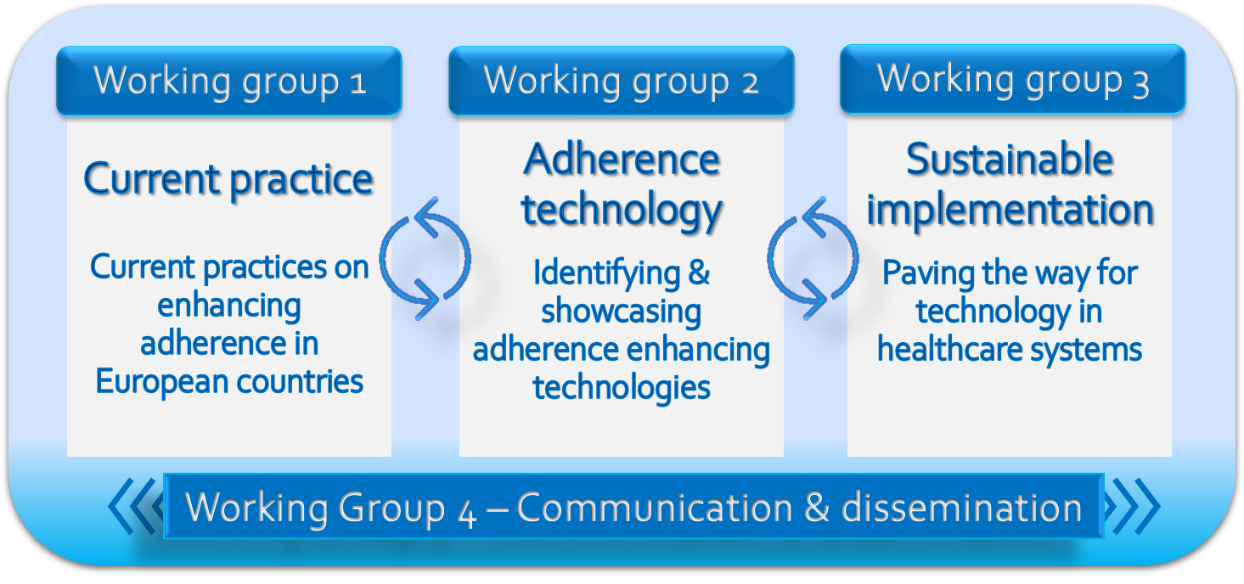
Figure 1- Working groups and respective aims of the COST Action ENABLE (CA19132 European Network to Advance Best Practices & Technology on Medication Adherence).

References
1. World Health Organization [WHO]. Adherence to Long-Term Therapies : Evidence for Action / [‎edited by Eduardo Sabaté]‎.; 2003. https://apps.who.int/iris/handle/10665/42682
2. Khan R, Socha-Dietrich K. Investing In Medication Adherence Improves Health Outcomes and Health System Efficiency: Adherence to Medicines for Diabetes, Hypertension, and Hyperlipidaemia.; 2018. doi:10.1787/8178962c-en
3. Wiecek E, Torres-Robles A, Cutler RL, Benrimoj SI, Garcia-Cardenas V. Impact of a Multicomponent Digital Therapeutic Mobile App on Medication Adherence in Patients with Chronic Conditions: Retrospective Analysis. J Med Internet Res. 2020;22(8):e17834. doi:10.2196/17834
4. Lapão LV, da Silva MM, Gregório J. Implementing an online pharmaceutical service using design science research. BMC Med Inform Decis Mak. 2017;17(1):31. doi:10.1186/s12911-017-0428-2
5. CA19132 - European Network to Advance Best practices & technology on medication adherence. https://www.cost.eu/actions/CA19132 (access date 16/04/2021).

