Supplementary material

The estimates were performed using R software (version 3.4.4). Code is available upon request.

Estimates of Excess Mortality per District in Portugal Mainland
Figure S1 shows graphical evolution of all-causes mortality by district of mainland Portugal (8 district out of 18) where it is clear that some districts (Aveiro, Porto and Lisbon) have marked excess mortality, while others is around or below the proposed baselines.
Figure S2 shows excess mortalities by district, using three baselines (median, mean +1 month and mean + 3 months). In absolute terms, higher mortality estimates are geographically superimposed with districts with higher number of COVID-19 cases (those districts are more densely populated).
Figure S3 shows the same data as Figure S2 presented in relative terms using district resident population. In relative terms, estimates for excess mortalities seem overall homogeneous by district, with a tendency to higher values in districts older and less dense populations.
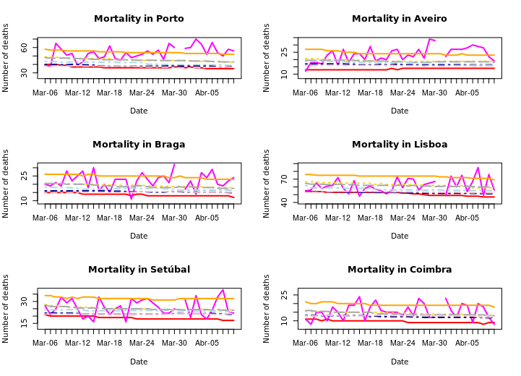
Figure S1a. Graphical illustration for district-specific distribution of all-cause mortality between March 6-April 8 for the Portugal Mainland Districts of Porto, Aveiro, Braga, Lisboa, Setúbal and Coimbra. Graphical comparison depicts observed mortality (magenta line), minimum baseline (red line), maximum baseline (orange line), mean baseline (yellow dashed line), median baseline (grey dashed line), mean + 1 month baseline (light blue dashed line), mean + 3 months baseline (dark blue dashed line) and mean + 5 months baseline (rose dashed line).
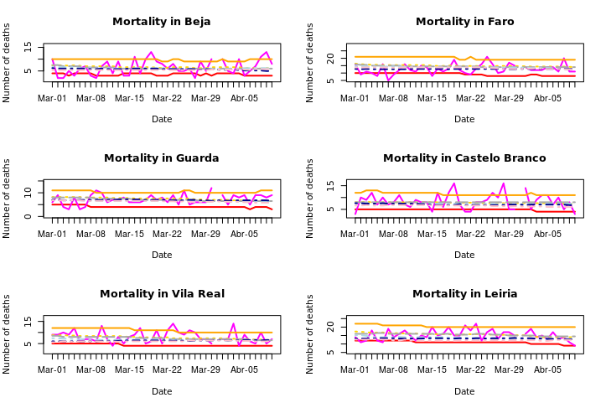
Figure S1b. Graphical illustration for district-specific distribution of all-cause mortality between March 6-April 8 for the Portugal Mainland Districts of Beja, Faro, Guarda, Castelo Branco, Vila Real and Leiria. Graphical comparison depicts observed mortality (magenta line), minimum baseline (red line), maximum baseline (orange line), mean baseline (yellow dashed line), median baseline (grey dashed line), mean + 1 month baseline (light blue dashed line), mean + 3 months baseline (dark blue dashed line) and mean + 5 months baseline (rose dashed line).
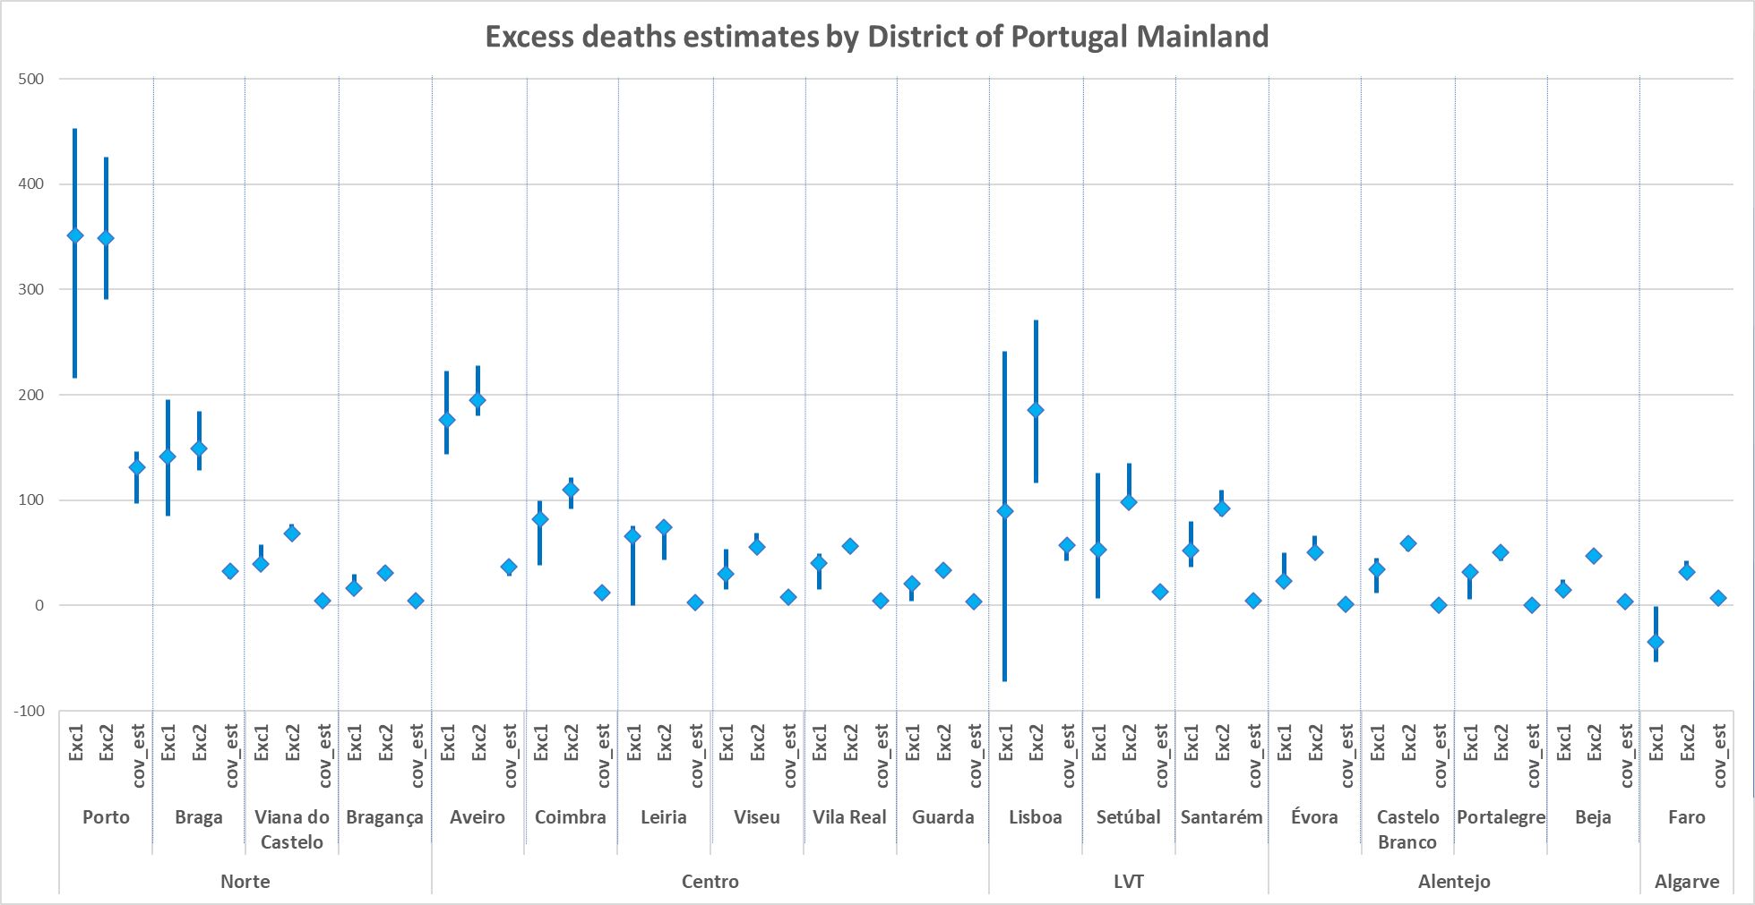
Figure S2. Graphical representation of estimated excess mortality rates and Covid-19 estimated mortality rates in absolute terms, both by 100,000 inhabitants per district. Vertical blue lines represent the distance between minimum and the maximum of estimated excess mortality calculated using 3 different baselines (median, mean + 1 month and mean + 3 months).
Notes for Figure S2:
  - Exc1 – estimated rate of excess mortality (sum of observed – sum of defined baseline) per 100,000 inhabitants.
  - Exc2 – estimated rate of excess mortality (sum of [observed –defined baseline] when this difference is positive) per 100,000 inhabitants.
  - In this figure, baselines used for excess estimation were i) median expected mortality, ii) mortality expected in average in the following month (+ 1 month); iii) mortality expected in average in three months (+ 3 months).
  - Cov-est – estimated rate of Covid-19 mortality per 100,000 inhabitants.

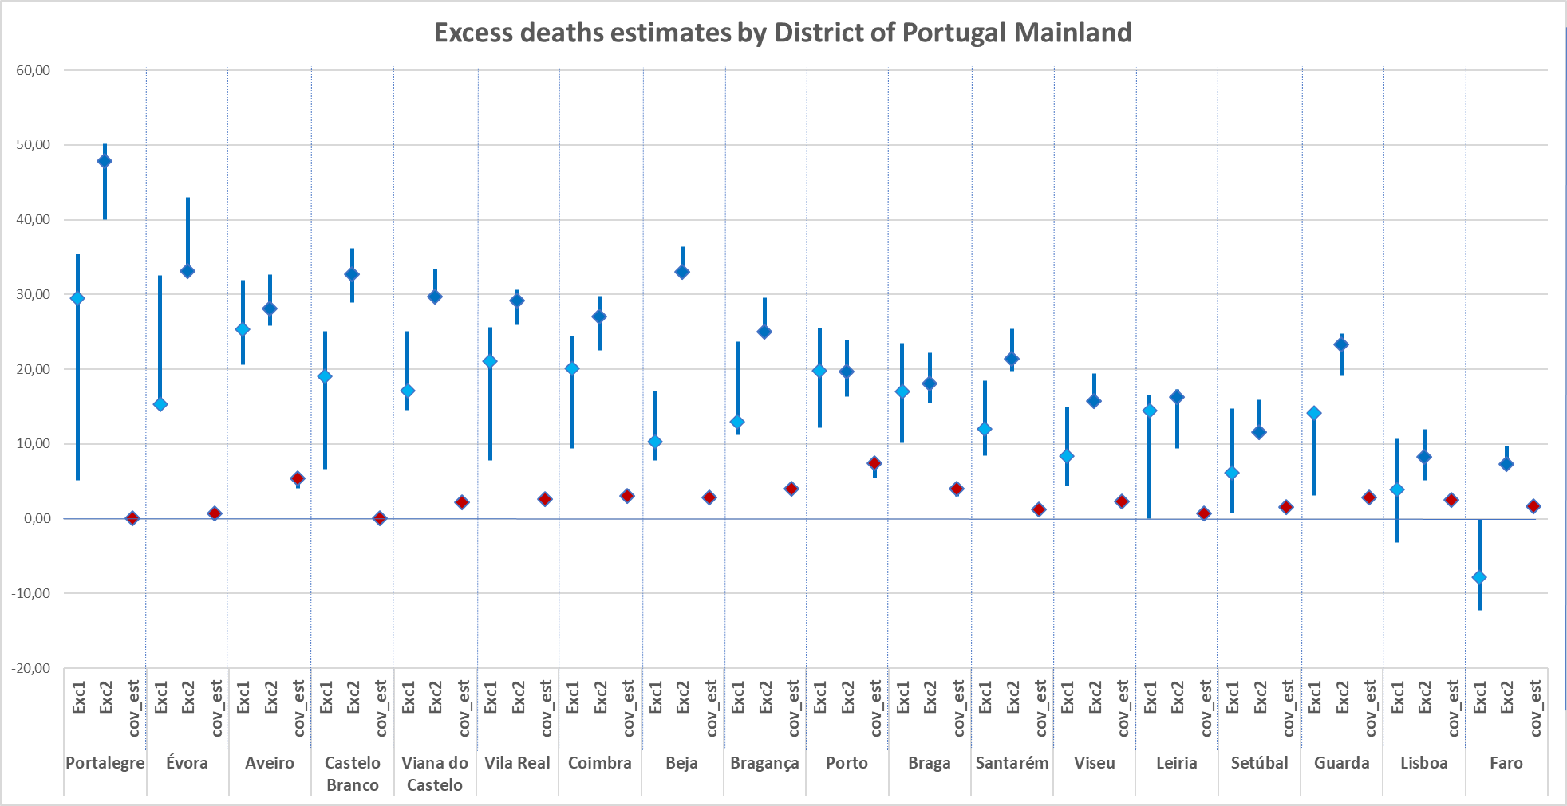
Figure S3. Graphical representation of estimated excess mortality rates and Covid-19 estimated mortality rates in relative terms, both by 100,000 inhabitants per district. Vertical blue lines represent the distance between minimum and the maximum of estimated excess mortality calculated using 3 different baselines (median, mean + 1 month and mean + 3 months)
Notes for Figure S3 :
  - Exc1 – estimated rate of excess mortality (sum of observed – sum of defined baseline) per 100,000 inhabitants.
  - Exc2 – estimated rate of excess mortality (sum of [observed –defined baseline] when this difference is positive) per 100,000 inhabitants.
  - In this figure, baselines used for excess estimation were i) median expected mortality, ii) mortality expected in average in the following month (+ 1 month); iii) mortality expected in average in three months (+ 3 months).
  - Cov-est – estimated rate of Covid-19 mortality per 100,000 inhabitants.
  - Covid-19 mortality was estimated from municipal cases reported by DGS using three hypothetical death rates (2%, 2.7% and 3%).

Estimate of the potential impact in mortality due to reduction of daily-rate hospital ED visits between March 1 – April 7
We retrieved the data on ED visits according to the Manchester Triage System¹ from a public database.² The estimate was performed in 3 steps:
Step 1- Three-day centered average counts of the daily visits between March 1 - April 7 were estimated as illustrated by Figure S4;
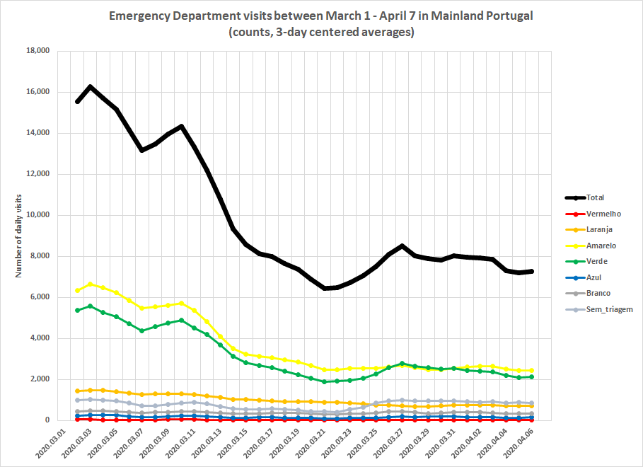
Figure S4. ED visits between March 1 - April 7 in Portugal Mainland (counts, 3-day centered averages). Color lines according to the 5-point scale of the Manchester Triage System in crescent order of severity: Blue, Green, Yellow, Orange, Red.¹
Step 2- The difference between those daily averages estimated in Step 1 was calculated for the same period for each Manchester System Triage color as demonstrated in Table S1;
We calculated the drop on the number of ED visits, according to the Manchester System Triage color in the following manner: for each triage color, we calculate the 3-day average in the beginning of march (1st to 3rd of march) (Step 1, Figure S4). From day 3 forward, within each color, we calculated the difference between the number of each day visits (3-day centered averages) and the 3-day average in the beginning of march (reference). The total number of visits presented in Table S1 (‘Difference between daily averages’) correspond to the sum of these daily differences, according to the triage color.
Step 3- The values obtained in step 2 for each Manchester System Triage color were multiplied by the correspondent death rate estimated from data of a Portuguese large hospital² and the values summed representing the number of potential deaths (Table S1).
Table S1. Average difference in ED visits between March 1 and April 7 in Portugal Mainland according to the Manchester Triage System.
 | Step 2 |  | Step 3
Manchester Triage System | Difference between daily averages | Death rate* | N potential deaths (step 2 * death rate)
Red color | |- 517| | 10.3 % | 53
Orange color | |-19457| | 4% | 778
Yellow color | |-108251| | 0.00003% | 3
Total number of deaths |  |  | 835
* Death rate per Manchester Triage System according to Martins et al. 2009 ²
Data for the remaining colors of the Manchester Triage System are not shown due to the non-significant contribution to the potential deaths.

Considering the previous steps and assumptions, it could be hypothesized an estimate of at least 835 deaths due to the reduction in ED department visits between March 1 and April 7. These potential 835 deaths are considered to be an underestimation of the real number of deaths.

Supplemental References
- Serviço Nacional da Saúde (SNS). Portal da transparência. Lisbon: SNS; 2020. Available from: https://transparencia.sns.gov.pt/explore/?sort=modified; assessed April 13, 2020.
- Martins HM, Cuña LM, Freitas P. Is Manchester (MTS) more than a triage system? A study of its association with mortality and admission to a large Portuguese hospital. Emerg Med J 2009; 26: 183-186.

