Supplementary material

The estimates were performed using R software (version 3.4.4). Code is available upon request.

Estimates of Excess Mortality per age groups
As indicated in the main document, we calculated excess mortality estimates considering Excess Mortality (Exc1)$(∑ observed - ∑ defined baseline)$ and Sum of Positive Excess Mortality (Exc2) $(∑ [observed - defined baseline] when this difference is positive)$. Tabel S1 shows the calculation of excess mortality using all-causes mortality by age group.

Table S1. Calculation of excess mortality using all-causes mortality by age group, up to the 8/4/2020 (available on the 11/4/2020)
 | 75+ age group |  | 65+ age group |  | <65 age group |  | <55 age group
Baseline | Exc1 | Exc2 | Exc1 | Exc2 | Exc1 | Exc2 | Exc1 | Exc2
Minimum | 1177 | 1733 | 1224 | 1894 | 49 | 180 | 41 | 105
Maximum | -672 | 388 | -852 | 420 | -571 | 10 | -375 | 0
Median | 260,5 | 959 | 170,5 | 1037 | -272 | 43 | -154 | 23
Mean | 170,2 | 902 | 95,4 | 977,2 | -270,2 | 42,6 | -151 | 24.4
Mean + 1 month | 947,2 | 1434,6 | 967,4 | 1574,2 | -203,6 | 41,8 | -132.8 | 21.2
Mean + 2 months | 1423 | 1763,6 | 1475,8 | 1927 | -197,8 | 39,2 | -137 | 20
Mean + 3 months | 1641,8 | 1925,6 | 1741,8 | 2131,2 | -176,6 | 46,2 | -127.6 | 23.6
Mean + 4 months | 1700,2 | 1953 | 1851,8 | 2192,2 | -199,6 | 36,8 | -141.8 | 17
Mean + 5 months | 1718,2 | 1981,6 | 1867,6 | 2211,4 | -202,6 | 40,2 | -148.8 | 18
Exc1 – Excess mortality $(∑ observed - ∑ defined baseline);$
Exc2 – Sum of positive excess mortality $(∑ [observed - defined baseline] when this difference is positive)$.

Table S1 results show that the estimated excess mortality is associated with the older patient age groups, with different baselines showing consistent results. Mortality in the younger age groups is, in average, below the proposed baselines as theorized.

Estimates of Excess Mortality per District in Portugal Mainland
Figure S1 shows graphical evolution of all-causes mortality by district of mainland Portugal (8 district out of 18) where it is clear that some districts (Aveiro, Porto and Lisbon) have marked excess mortality, while others is around or below the proposed baselines.
Figure S2 shows excess mortalities by district, using three baselines (median, mean +1 month and mean + 3 months). In absolute terms, higher mortality estimates are geographically superimposed with districts with higher number of COVID-19 cases (those districts are more densely populated).
Figure figure S3 shows the same data as Figure S2 presented in relative terms using district resident population. In relative terms, estimates for excess mortalities seem overall homogeneous by district, with a tendency to higher values in districts older and less dense populations.

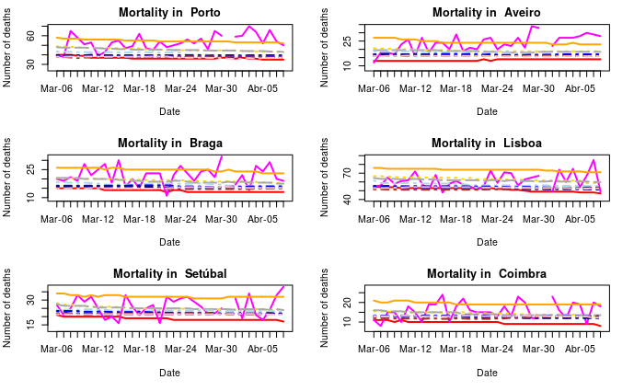
Figure S1a. Graphical illustration for district-specific distribution of all-cause mortality between March 6-April 8 for the Portugal Mainland Districts of Porto, Aveiro, Braga, Lisboa, Setúbal and Coimbra.
.
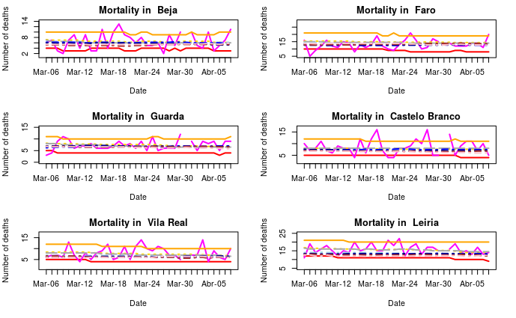
Figure S1b. Graphical illustration for district-specific distribution of all-cause mortality between March 6-April 8 for the Portugal Mainland Districts of Beja, Faro, Guarda, Castelo Branco, Vila Real and Leiria.
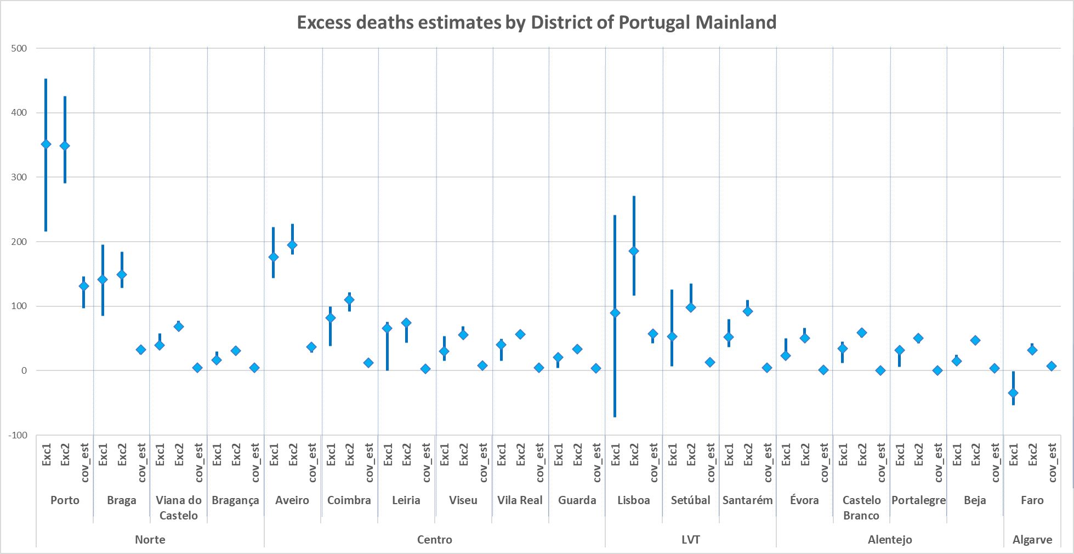
Figure S2. Graphical representation of estimated excess mortality rates and Covid-19 estimated mortality rates in absolute terms, both by 100,000 inhabitants per district.
Notes for Figure S2::
  - Exc1 – estimated rate of excess mortality (sum of observed – sum of defined baseline) per 100,000 inhabitants.
  - Exc2 – estimated rate of excess mortality (sum of [observed –defined baseline] when this difference is positive) per 100,000 inhabitants.
  - In this figure, baselines used for excess estimation were i) median expected mortality, ii) mortality expected in average in the following month (+ 1 month); iii) mortality expected in average in three months (+ 3 months).
  - Cov-est – estimated rate of Covid-19 mortality per 100,000 inhabitants.

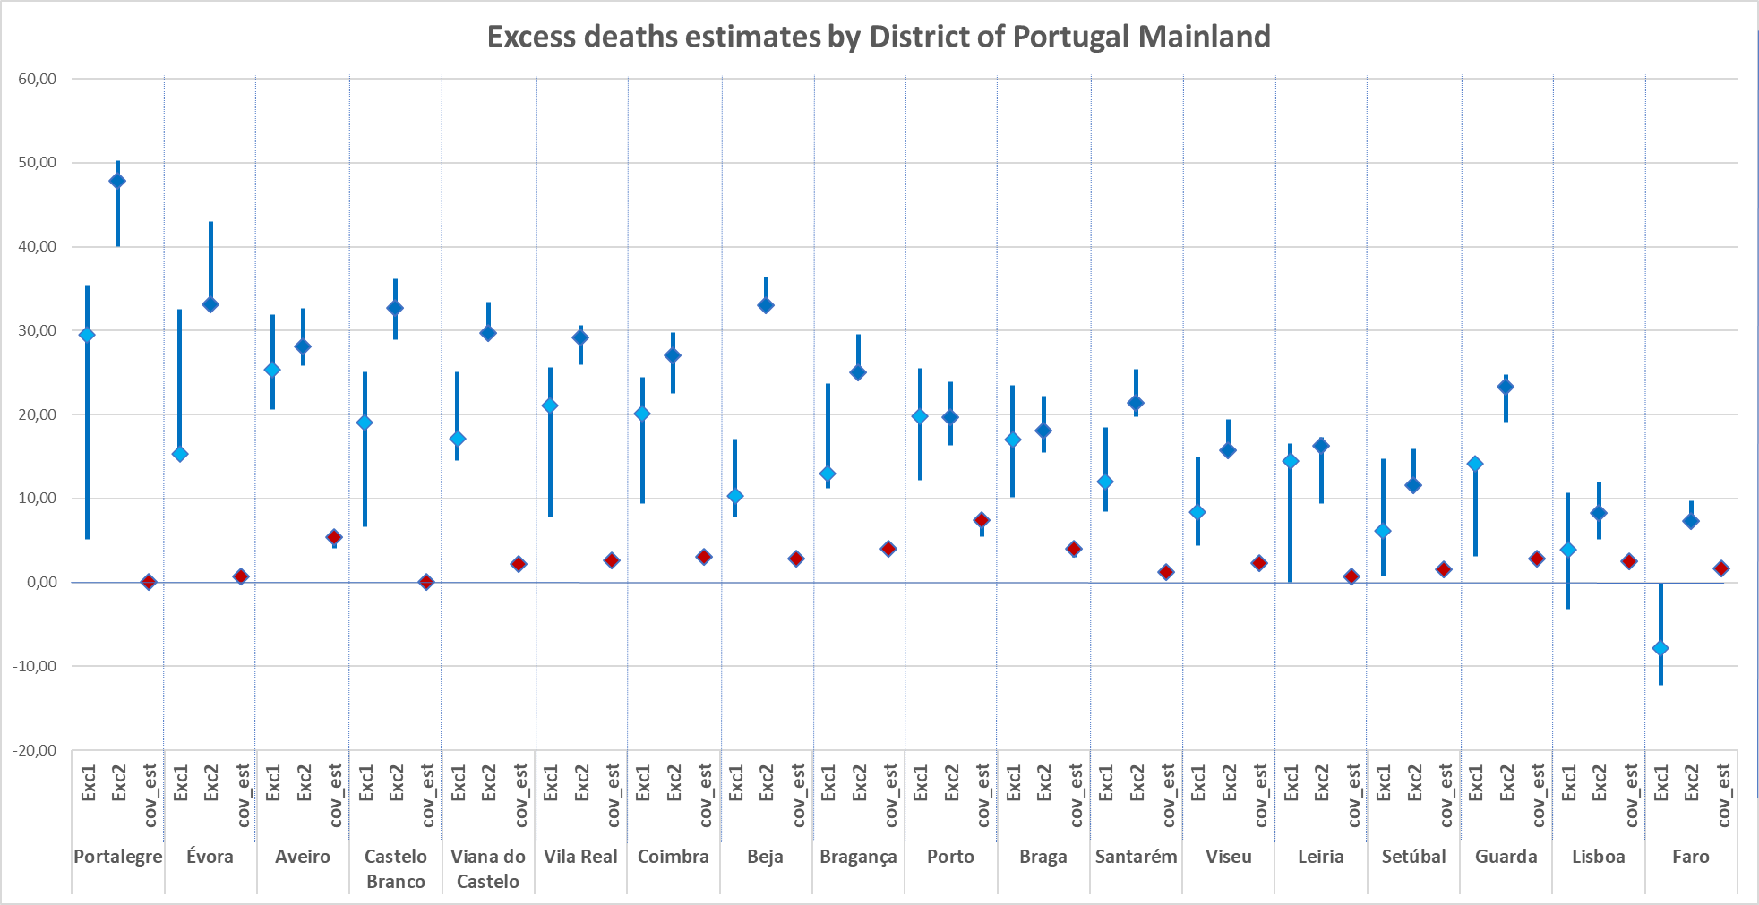
Figure S3. Graphical representation of estimated excess mortality rates and Covid-19 estimated mortality rates in relative terms, both by 100,000 inhabitants per district.
Notes for Figure S2::
  - Exc1 – estimated rate of excess mortality (sum of observed – sum of defined baseline) per 100,000 inhabitants.
  - Exc2 – estimated rate of excess mortality (sum of [observed –defined baseline] when this difference is positive) per 100,000 inhabitants.
  - In this figure, baselines used for excess estimation were i) median expected mortality, ii) mortality expected in average in the following month (+ 1 month); iii) mortality expected in average in three months (+ 3 months).
  - Cov-est – estimated rate of Covid-19 mortality per 100,000 inhabitants.
  - Covid-19 mortality was estimated from municipal cases reported by DGS using three hypothetical death rates (2%, 2.7% and 3%).

Estimate of the potential impact in mortality due to reduction of daily-rate hospital urgency department visits between March 1 - April 7
We retrieved the data on urgency department visits according to the Manchester Triage System[1] from a public database [2]. The estimate was performed in 3 steps:
Step 1- Three-day centered average counts of the daily visits between March 1 - April 7 were estimated as illustrated by Figure S4;
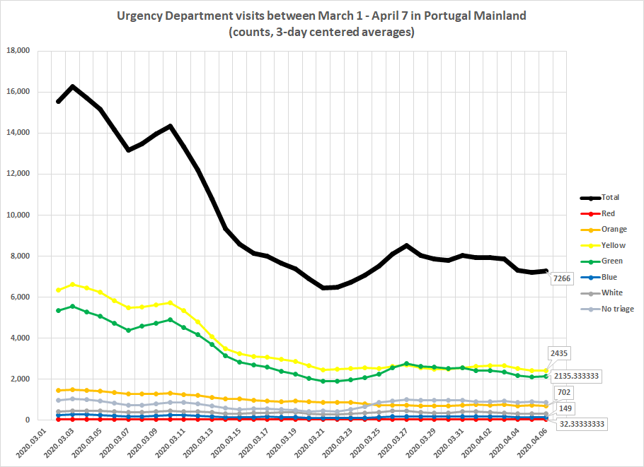
Figure S4. Urgency department visits between March 1 - April 7 in Portugal Mainland (counts, 3-day centered averages). Color lines according to the 5-point scale of the Manchester Triage System in crescent order of severity: Blue, Green, Yellow, Orange, Red [1].
Step 2- The difference between those daily averages estimated in Step 1 was calculated fo the same period for each Manchester System Triage color as demonstrated in Table S2;
Step 3- The values obtained in step 2 for each Manchester System Triage color were multiplied by the correspondent death rate estimated from data of a Portuguese large hospital [2] and the values summed representing the number of potential deaths (Table S2).

Table S2. Average difference in urgency department visits between March 1 and April 7 in Portugal Mainland according to the Manchester Triage System.
 | Step 2 |  |  |  | Step 3
Manchester Triage System | Difference between daily averages |  | Death rate* |  | N potential deaths (step 2 * death rate)
Red color | |- 517| |  | 10.3 % |  | 53
Orange color | |-19457| |  | 4% |  | 778
Yellow color | |-108251| |  | 0.00003% |  | 3
Total number of deaths |  |  |  |  | 835
* Death rate per Manchester Triage System according to Martins et al. 2009 [2]
Data for the remaining colors of the Manchester Triage System are not shown due to redundancy.

Considering the previous steps and assumptions, it could be hypothesized an estimate of at least 835 deaths due to the reduction in Urgency department visits between March 1 and April 7. These potential 835 deaths are considered to be an underestimation of the real number of deaths.

Supplemental References
- Serviço Nacional da Saúde (SNS). Portal da transparência. Lisbon: SNS; 2020. Available from: https://transparencia.sns.gov.pt/explore/?sort=modified; assessed April 13, 2020.
- Martins HM, Cuña LM, Freitas P. Is Manchester (MTS) more than a triage system? A study of its association with mortality and admission to a large Portuguese hospital. Emerg Med J 2009; 26: 183-186.

