PÁGINA DE TÍTULO

TÍTULO: Mama tuberosa
TITLE: Tuberous breast

AUTORES:
Joana Simões da Silva
Médica Interna de Medicina Geral e Familiar
USF Águeda + Saúde

Paula Alves Teixeira
Médica Interna de Medicina Geral e Familiar
USF Águeda + Saúde

Maria Teresa Rosmaninho
Assistente Graduada de Medicina Geral e Familiar
Diretora de Internato de Medicina Geral e Familiar do núcleo Aveiro Sul
USF Águeda + Saúde

SUBSÍDIOS OU BOLSAS
Não existiram fontes externas de financiamento para a realização deste artigo.

ENDEREÇO PARA CORRESPONDÊNCIA:
Joana Simões da Silva
USF Águeda + Saúde
Avenida Caloust Gulbenkian, 173
3750-102 Águeda
Telefone: +351912737136
E-mail: joanasimoess87@gmail.com

TÍTULO BREVE: Tuberous Breast

TITLE: Tuberous breast
A 22 year-old female patient, with no relevant medical history complained about the shape of her breasts, which had been the source of her low self-esteem since early adolescence. A physical examination revealed asymmetrical, tubular hypoplastic breasts and enlarged areolas (Fig. 1). The patient was referred to the Plastic Surgery Department of the referral hospital, where a diagnosis of type III tuberous breast was made and reconstructive surgery with (breast) implants was proposed (Fig. 2).
Tuberous breast is a rare deformity¹ with onset at the beginning of pubertal growth¹⁻³. The main signs are hypoplasia and tubular shape of the breast, which may be uni or bilateral, symmetric or asymmetric^{2,3}. The diagnosis is clinical and the treatment is surgical. This pathology conveys a significant psychological burden, causing low self-confidence, anxiety, depression, peer rejection and psychosexual dysfunction^{1,3}. Early diagnosis and surgical correction are key in the treatment and prevention of the psychological symptoms³.

KEYWORDS: Breast; Tuberous Breast; Plastic surgery

IMAGES
1
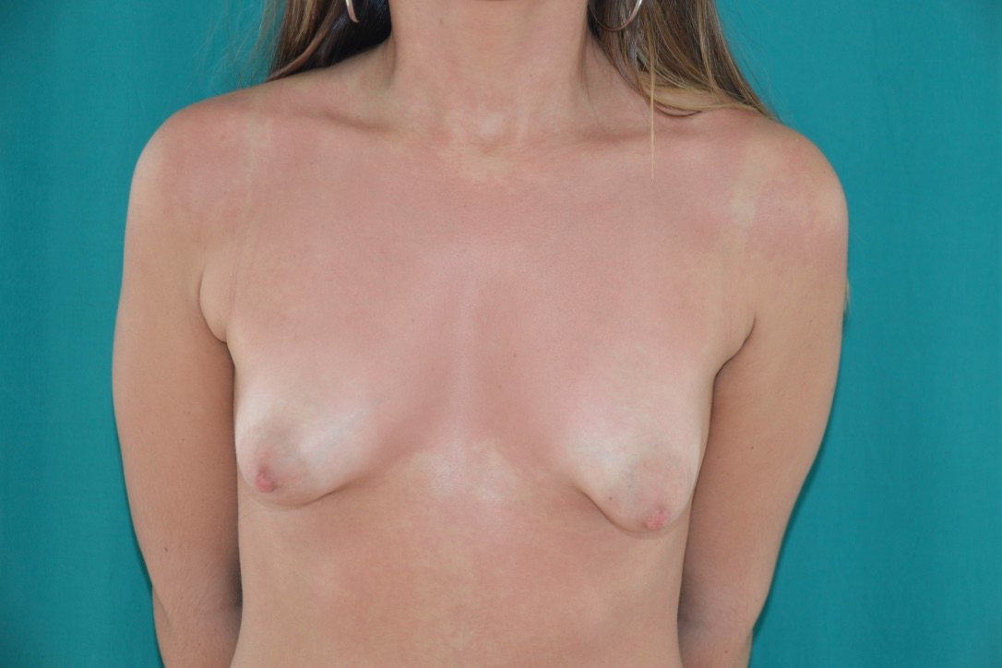

2
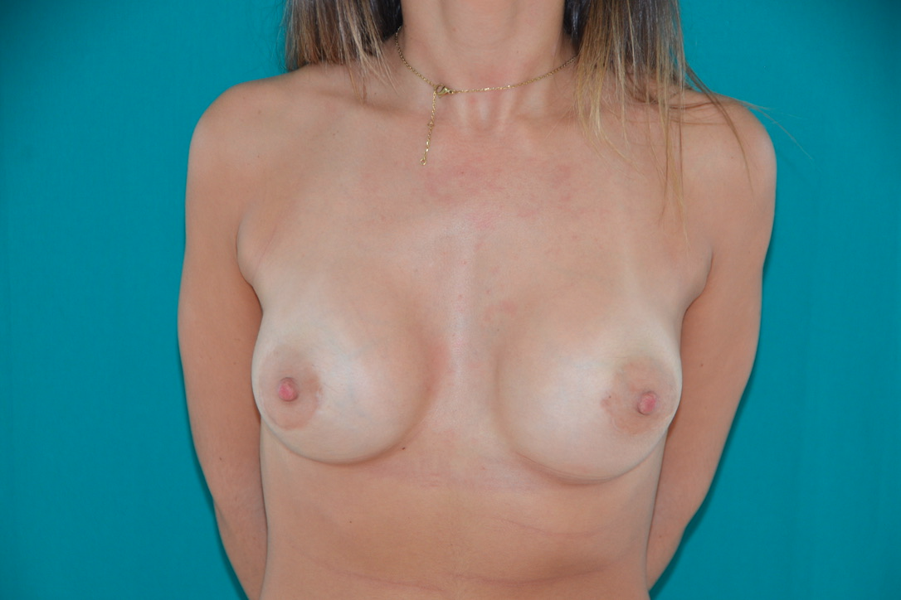
3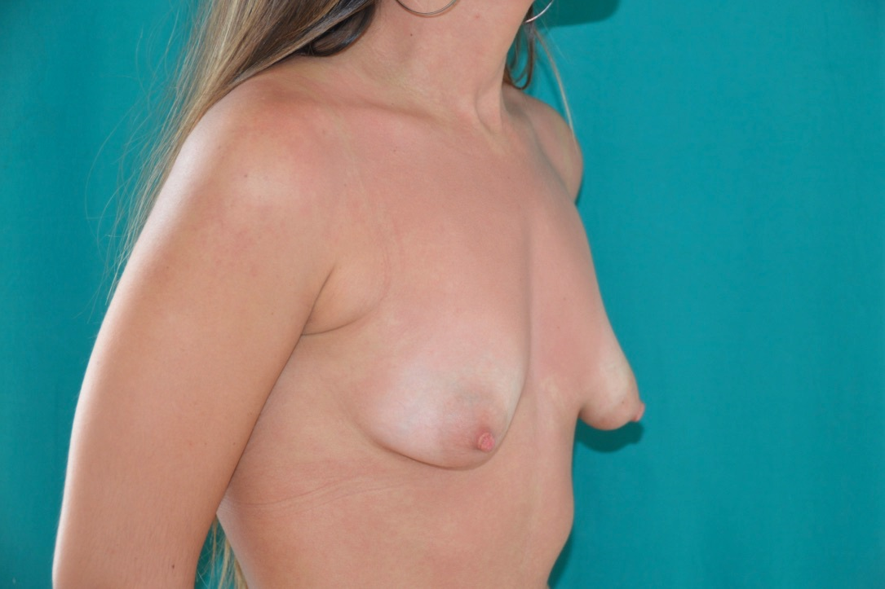

4

5
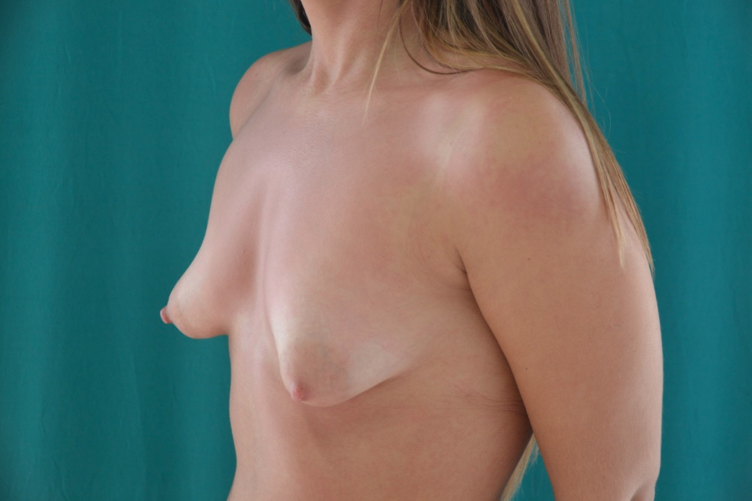

6
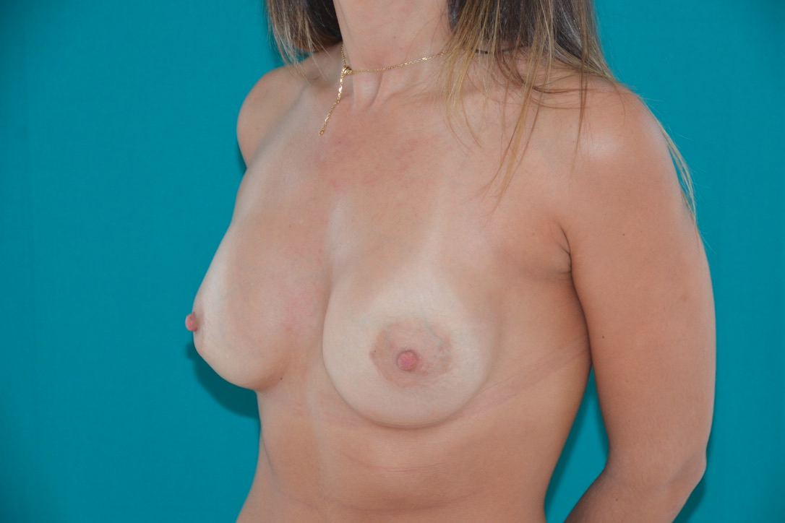

REFERENCES:
1-Dessy LA, Mazzocchi M, Corrias F, Sorvillo V, Scuderi N. Correction of tuberous breast with small volume asymmetry by using a new adjustable implant. European Review for Medical and Pharmacological Sciences 2013; 17: 977-983.
2-Silva-Vergara C, Fontdevila J, Weshahy O. Fat Grafting Technique, A Paradigm Shift in the Treatment of Tuberous Breast. World J Plast Surg. 2018 Jan;7(1):72-77.
3-Winocour S, Lemaine V. Hypoplastic Breast Anomalies in the Female Adolescent Breast. Semin Plast Surg 2013;27:42-48.

LEGENDS

Figure 1: Preoperative tuberous breast
Figure 2: Periareolar surgical correction and subfascial breast augmentation with anatomical textured implants (size 255 cc).
Figure 3: Preoperative tuberous breast – lateral view
Figure 4: Periareolar surgical correction and subfascial breast augmentation with anatomical textured implants (size 255 cc) – lateral view.
Figure 5: Preoperative tuberous breast – lateral view
Figure 6: Periareolar surgical correction and subfascial breast augmentation with anatomical textured implants (size 255 cc) – lateral view.

