Figure 1 – Distribution of the sample by quartiles of the Rey Complex Figures copy and memory reproduction (n=120)

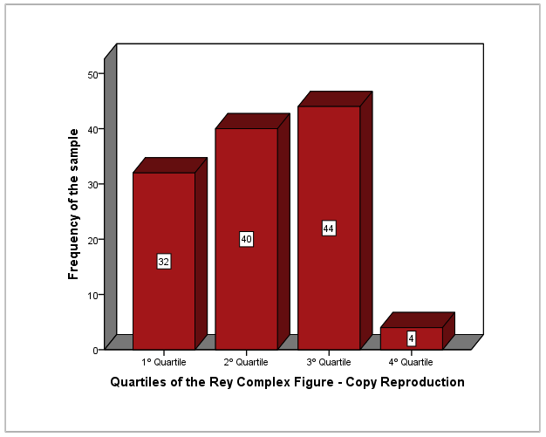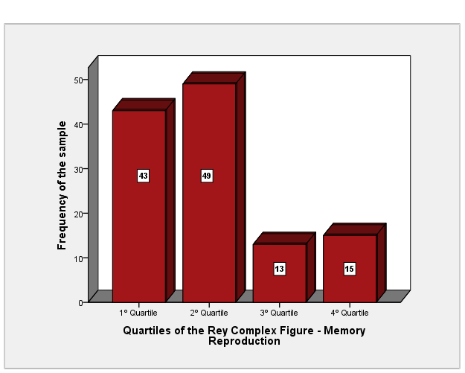

Figure 2 – Distribution of the sample by quartiles of the global severity index and positive symptom distress index of the Symptom Checklist-Revised (n=120)

