RESPOSTA AOS COMENTÁRIOS DO REVISOR B

NOTA DO EDITOR, do Revisor B
Revisor B: Vide também documento carregado no portal da Acta Médica
Portuguesa
RESPOSTA à Nota do EDITOR RELATIVA AO Revisor B
Os autores informam que responderam a cada comentário do Revisor B, no próprio documento do AO, agora sem track changes.

COMENTÁRIO 1, Revisor B
I strongly recommend a thorough review by an English native speaker.
RESPOSTA 1, COMENTÁRIO 1, Revisor B
Os autores informam que responderam ao Editor Chefe e Coordenação Editorial, enviando o certificado da empresa que validou o texto, devidamente certificada pela FCT.

ABAIXO O ARTIGO – COM OS COMENTÁRIOS – APENAS DO REVISOR B – com RESPOSTAS PARA O REVISOR B.

Título: Consumo de álcool e drogas na população escolar de São Tomé e Príncipe
Title: Consumption of alcohol and drugs in the school population of Sao Tome and Principe

Authors: De Santiago, Isabel1st, Ribeiro, Ruy M.2nd, Bacelar Nicolau, Leonor3^{rd,} Marinho, Rui 4th, Pereira-Miguel, José5th
Affiliation (Department Name of Organization, Name of Organization, City, Country): 1stPublic Health Communication at Instituto de Medicina Preventiva e Saúde Pública, Faculdade de Medicina, Universidade de Lisboa, Lisboa, Portugal; 2ndLaboratório de Biomatemática, Instituto de Medicina Preventiva e Saúde Pública, Faculdade de Medicina, Universidade de Lisboa; 3rdHealth Economics, Instituto de Medicina Preventiva e Saúde Pública, Faculdade de Medicina, Universidade de Lisboa, Lisboa, Portugal; 4th Serviço de Gastrenterologia e Hepatologia, Centro Hospitalar Universitário de Lisboa Norte EPE, Hospital Universitário de Santa Maria and Faculdade de Medicina, Universidade de Lisboa, Portugal; 5th Instituto de Medicina Preventiva e Saúde Pública, Faculdade de Medicina, Universidade de Lisboa, Lisboa, Portugal.

Morada: Instituto de Medicina Preventiva e Saúde Pública, Faculdade de Medicina da Universidade de Lisboa.
Av. Prof. Egas Moniz. 1649-028 Lisboa, Portugal

Email: 1^{st:} isabeldesantiago@medicina.ulisboa.pt

Não existe conflito de interesses
Apoio financeiro a declarar: Associação Nacional de Farmácias (2 viagens de avisão para duas conferências científicas internacionais e apresentação de resultados IUPHE Curitiba-Brasil Maio de 2016 e CDC e Atlanta-USA Agosto 2016).

Cabeçalho PT: ÁLCOOL e DROGAS em SÃO TOMÉ e PRÍNCIPE

Header ENG: ALCOHOL and DRUGS in SAO TOME and PRINCIPE

Título: Consumo de álcool e drogas na população escolar em São Tomé e Príncipe

RESUMO
Introdução: Em São Tomé e Príncipe não há estudos sobre o uso de álcool e drogas na população escolar, potencial aliada em intervenções preventivas. Os objetivos do presente estudo são 1) determinar a frequência do consumo de álcool e drogas na população escolar e 2) identificar as principais características associadas a estes comportamentos.
Materiais e Métodos: Foi aplicado um questionário biográfico, demográfico e socioeconómico sobre o uso de substâncias lícitas e ilícitas para uma amostra de 2064 alunos. As características demográficas e sociais apresentadas baseiam-se nas frequências observadas e as comparações entre os grupos foram feitas usando testes de qui-quadrado. A significância foi avaliada em α=0.05.
Resultados: Mais da metade dos alunos consumiram álcool pelo menos uma vez na vida e 32% nos últimos 30 dias. Os alunos mais velhos mostraram-se mais propensos a consumir álcool (p <0,0001), mas mesmo nos alunos com idade inferior a 16 anos, 17% consumiram nos últimos 30 dias. Constatou-se também que entre todos os alunos, 7% consumiram uma ou mais vezes por semana nos últimos 30 dias. As razões apresentadas para o consumo frequente foram diferentes para os rapazes (“participação no grupo de amigos”) e raparigas (“diminuição da ansiedade”) (p = 0,005). Menos de 1% dos entrevistados admitiram ter usado maconha, cocaína, crack ou ecstasy.
Discussão: Apesar de algumas limitações, como o auto reporte, publica-se um primeiro diagnóstico de situação mostrando um elevado consumo de álcool pelos jovens e ainda a utilização de drogas ilegais nas escolas.
Conclusão: Estes resultados levam a concluir que é urgente o desenvolvimento de intervenções preventivas, nomeadamente, no âmbito da comunicação em saúde pública.

Palavras-Chave: Países africanos, álcool, droga, escolas, estudantes.

Title: Consumption of alcohol and drugs in the school population of Sao Tome and Principe

ABSTRACT
Introduction: In São Tomé and Príncipe there are no studies on alcohol and drug use among students, who could be potential allies in preventive interventions. The objectives of the present study are 1) to determine the frequency of alcohol and drug consumption in the school population, and 2) to identify the main characteristics of this behaviour.
Materials and Methods: We applied a biographical, demographic and socio-economic questionnaire on the use of licit and illicit substances to a sample of 2064 students. Demographic and social characteristics are presented based on observed frequencies and comparisons between groups were made using chi-square tests. Significance was assessed at α=0.05.
Results: More than half of the students consumed alcohol, at least once, in their lifetime and 32% consumed in the last 30 days. Older students were more likely to consume alcohol (p <0.0001), but even in students under 16 years, 17% consumed in the last 30 days. We also found that 7% consumed one or more times per week in the last 30 days. The reasons presented for frequent consumption were different for boys (“participation in their group of friends”) and girls (“decrease anxiety”) (p = 0.005). Less than 1% of respondents admitted to having used marijuana, cocaine, crack or ecstasy.
Discussion: In spite of some limitations, such as self-reporting, we provide a first picture showing high consumption of alcohol by young people and the existence of illegal drugs circulating in the schools.
Conclusion: These results lead us to conclude that it is urgent to implement public health communication preventive interventions.

Keywords: African countries, alcohol, drug, school, students.

No Conflict of Interests
Financial support to declare: Associação Nacional de Farmácias (support to attend two scientific conferences for presentation of results:at IUPHE Curitiba-Brazil in May 2016 and CDC in Atlanta-USA August 2016).

Introduction

African Countries (AC), are mostly, low-and middle income countries (LMIC), where extreme poverty^{1,2} causes considerable health inequalities^{3,4}. Sao Tome and Principe (STP), the smallest of them, presents a socio-epidemiological reality⁵ characterized by the almost absence of healthy lifestyles^{6,7}, formal education and health communication policy^{7–10}. There is wide consumption of alcohol and drugs (A&D), but no systematic research has been done, only overall statistics are available based on the importation of alcoholic drinks and their distribution among the population^{8,9,11}. In fact, the World Health Organization (WHO) “Global Status Report on noncommunicable diseases 2014” is the only survey¹² in Africa dealing with A&D consumption and its harmful use, but it presents only aggregated data.

According to the WHO, globally, alcohol use results in 3.3 million deaths⁷. Heavy consumption of alcohol, an oncogenic substance, is believed to be a risk factor for cancer^{13–15} (also in STP¹⁶), due to more than a hundred medical reasons, as well as a risk for other non-communicable diseases (NCD)⁷¹⁷, such as mental and behavioral disorders and it is also responsible for injuries, traffic accidents ^{6,18–20} and deaths^{21,22}. Thus, the situation constitutes a serious threat to public health³. It is difficult to judge the level of alcohol intake, because the scientific community is often unaware of all types of artisanal alcohol (outside the commercial circuit) produced in STP²³ (without regulatory legislation and no sanitary control) and consumed by local communities^{24,25}. For example, in STP, the most common forms of alcohol are “cacharamba”, “chalelinha” and “tomatxo”, a distilled drink (sugarcane, mango, cajamanga fruit and pineapple), and palm wine produced locally. The WHO reports, in 2014 estimates, that this unrecorded consumption for people older than 15 years¹¹ in STP is 2.9 litres per capita of the total 7.1 litres per capita estimated for 2008-2010. They also estimate much heavier drinking in males (11.5 litres per capita) then in females (2.9 litres per capita)^{11,19}. WHO also estimates that more females (72.6%) than males (50.6%) are abstainers in the last 12 months²⁶. However, there is no data specific to young people^{27,28} (school population) or on the effects of alcohol on NCD^{28–30} or deaths in STP^{7,19,21}.

Young people are vulnerable^{6,25,26} to developing habits of harmful alcohol consumption^{27,31–33}, with important life-time implications for their health. The risk of future addiction is very high if “binge” drinking begins at 15 years. In addition, some preventive interventions (Health promotion and risk reduction)³⁴ to reduce alcohol^{35–38} and drugs^{27,37} consumption, such as health communication^{35,39–42}, are recommended for younger populations⁴³, as a health priority^{44,45}. As a base to develop intervention priorities, the present study analyzed the frequency and distribution of alcohol and drug consumption in the public-school population, and identified and characterized the profile of consumers^{46–48}.

Materials & Methods

National survey
We conducted a cross sectional, observational study with a questionnaire-based survey of the student population (public schools and university) of STP between September 2013 and May 2014. We interviewed a sample of students from three settings: grades 8 to 12 in public secondary education; public university and night school; and professional and qualification training. We emphasize that typically these levels of schooling include students aged 12-18; 18-25; and older respectively. The anonymous questionnaire included biographic, demographic and socio-economic^{26,49} questions, as well as questions about the use of licit and illicit substances³⁷. The survey instrument was developed specifically for this study, in Portuguese language adapted to the local dialect forro. The questionnaire was first validated based on a pilot survey of a convenience sample of 150 male and female students, including analyses of comprehension of the questions and translation. This questionnaire is included in the appendix. For the main study, from the total population of 16924 students in public schools and the Instituto Superior Politécnico, now part of the University of Sao Tome and Principe, we obtained a sample of 2064 individuals (12% of the total). This sample included students from all public schools of Sao Tome and Principe, and each school was sampled proportionally to its student population size. This sampling was done in coordination with the school’s Principal and for each school, random classes, with approximately equal numbers of boys and girls, were chosen to answer the questionnaire, so in each school we sampled classes not students for logistical reasons. The students from the classes selected were instructed about the objectives of the research, the anonymity of the questionnaire and that they were not under obligation to answer it or any of the questions. Thus, filling the anonymous questionnaire corresponded to informed consent. A sample with this size has associated a maximum error of estimation for the proportions analyzed of 2%, for a confidence level of 95% [cite: Ryan, Thomas P. “Sample Size Determination and Power” Wiley. New Jersey, USA _(2013), chapter 2].

Approval by all relevant authorities of STP including the Ministry of Educação, Cultura e Formação and the Directorate of Ensino Secundário (Secondary Education) was obtained before application of the questionnaire. In addition, the study was approved by the Ethics Committee of Centro Hospitalar de Lisboa Norte, Faculdade de Medicina da Universidade de Lisboa and Centro Académico de Medicina de Lisboa (Reference number 47/16).

Statistical analyses
We present the results of descriptive statistical analyses of the data, and comparisons between groups that were done using chi-square test or Fisher exact test, if necessary. Since answering each question was optional, some of the variables may not have data for the full 2064 participants. In each figure, we present the number of respondents for the specific question being analysed. The analyses were done using IBM SPSS, 24 version. We considered a significance level of α=0.05.

(Insert figure 1)

Results

Overall alcohol consumption habits
This study analysed the sociodemographic characteristics of the alcohol and drug consumption habits of the school-aged population of the islands of STP. From the total 2064 individuals surveyed 52% were male and 48% were female. The age limits were 12 - 30, median 18-years old. We sampled students from all public schools in Sao Tome and Principe, including all districts (Figure 1). The students were attending secondary school (56%, median age=17, interquartile range= 3); night school & illiteracy classes (30%, m=21, IQR=8); technical education (9%, m=21, IQR=4); and higher education (5%, m=22, IQR=5).

(insert figure 2)

Half of the students admitted having consumed alcohol at least once in their lifetime (Figure 2), 29% consumed alcohol over the previous 30 days, with 22% stating that they consumed less than once a week and 7% once or more times per week (Figure 3). In addition, a proportion of 23% acknowledged that they have friends who get drunk on a weekly basis, and of these, 1/3 say that many or all of their friends do get drunk. These numbers may be an underestimate, since they are based on self-reporting and between 7% and 12% of students refused to answer some of these questions. (Figure 2 and Figure 4).

(Insert figure 3)

Demographic characterization of alcohol consumption
Next, we analysed the demographic characteristics of alcohol consumption among the student population. Overall, male students are more prone to drinking alcohol than female students, with 58% vs. 43%, respectively, saying that they did at least once in the past (Figure 4). This difference was statistically significant (χ²=42.55, p= 7×10⁻¹¹). The female students also drink less frequently, with 25% stating that they consumed over the last 30 days, in comparison to 38% of male students doing so. However, if we focus only on these students, who did consume over the last 30 days, the frequency (<1/week vs. ≥1/week) of consumption does not reach statistical difference between males and females (27% vs. 20% consume ≥1/week, respectively, χ²=3.26, p=0.071).

(Insert figure 4)

There was a very strong association between alcohol consumption and age (χ²=176.96, p= 2.4×10⁻³⁶), with higher percentages of older students having tried alcohol before (we stratified age as in Figure 4). This is perhaps expected due to a cumulative effect of “having tried alcohol before”. But even in the two younger age groups (<14 years and 15-16), about 35% indicate that they have consumed alcohol before, and 17% consumed over the last 30 days. Even though 69% of students older than 25 had consumed alcohol before, this was less than the 20-25 age group (74%), but this difference is not significant (χ²=1.68, p=0.19). When we analysed only those who stated they had drunk alcohol in the last 30 days, perhaps regular drinkers, there was no association between age and drinking level (<1/week or ≥1/week) (χ²=10.46, p=0.063). For example, for the ages between 15 and 25, about 20% to 27% of those who drank in the last 30 days, did so frequently (≥1/week) (Figure 4).

We also analysed the geographical disparities in alcohol consumption in STP (Figures 1 and 4). We were especially interested to see any differences due to income levels in the different districts. However, we found that the highest consumptions were in Água Grande and Lembá, which are the richest and poorest districts of STP, respectively. In these districts, 56% and 57%, respectively, of students refer drinking alcohol at least once before.

Social characterization of alcohol consumption
Students attending night school and literacy classes (57%), technical training (76%) and higher education (79%) present a higher percentage of having consumed alcohol before than students in regular day time high school (40%) (Figure 4). However, this may be related to the older age of students in those educational contexts, indeed the median age of students in regular high school is 17 vs. 21 in the other three types of educational setting. As expected, the frequency of drinking is also different with 5% of students in daytime secondary school affirming that they consumed more than once a week in the last 30 days, versus 11.3% for the students in the other educational settings. The mother’s education level does not seem to influence past alcohol consumption: 49% of students with mothers lacking formal education have consumed in the past, compared with 52% of the children of mothers with the secondary cycle incomplete and 45% for the case of completed higher education (χ²=4.79, p=0.091) (Figure 3). The mother’s education level was also not associated with the frequency of drinking (χ²=6.49, p=0.165, using three categories of drinking frequency none, <1/week and ≥1/week). On the other hand, the actual alcohol/drug consumption habits of mother or father were associated with student drinking, with more of them having tried alcohol at least once if their mother or father are regular users (χ²=19.81, p=9×10⁻⁶ and χ²=13.79, p=0.0002, respectively). Interestingly, this association does not affect students who drink regularly or heavily (more than once a week in the last 30 days), since about 7%-9% report this behaviour, independently of whether their father or mother drink regularly or not. The biggest difference is that substantially more students report drinking occasionally (less than once a week over the last 30 days), if their mother or father also consume.

When asked why they consume alcohol frequently, the 109 students, who admitted to that (and also answered this question), chose as the main reason “to participate in their peer group” (52%), “to break routine or enjoy the effects” (19%), “to relieve anxiety or stress” (26%), and “to relief abstinence symptoms” (3%). But these percentages were very different for males and females (p=0.005 by generalized Fisher test), with the former choosing the first reason 58% of the time vs. 37% for girls, whereas females chose “relieving anxiety” 50% vs. 17% for boys.

Illicit drug consumption habits
We also asked about consumption of illicit drugs, but very small numbers of students admitted to this, with 1% or less having tried marijuana, cocaine, crack and/or ecstasy before (Figure 2). These small numbers do not allow us to characterize this behaviour in any more detail.

Discussion

Alcohol and drug consumption in the Republic of Sao Tome and Principe^{11,26,50} is a potential serious threat to public health^{51,52}, with high losses of lives and DALY^{5,17} and without appropriate preventive interventions^{53,54}, such as legislation or public health communication preventive policies^{39,55}. The Government acknowledges the problem of excessive alcohol consumption, but no legislation has yet regulated artisanal alcohols^{24,25}, produced in the community and sold freely to everyone, including young children. The situation is even worse due to lack of social and health education^{25,56} and communication policies⁵⁷ empowering students^{38,58} and youth in general for preventive behaviours^{59,60}.

In this study, we provide a first picture of the habits of alcohol and drug consumption in the school population. We found high levels of experience with alcohol, and a worrying percentage of regular drinkers^{19,25} (~30%). There were differences between males and females, and among age groups, in their lifetime consumption habits. However, an interesting result is that when we focused only on those students who consumed in the last 30 days, differences by sex and age were much less evident. This may indicate that there is a group of regular consumers, who have socio-demographic characteristics different from the overall student population. Such a possibility should be taken into account when defining intervention strategies^{28,33}. The issue of a potential group of “regular consumers” is reinforced by our findings that heavy drinkers²⁸ among the student population⁶¹ were not associated with the consumption habits of the parents, although general consumption habits of students (for example, being “occasional drinkers”) were associated with parents’ consumption behaviour. Overall, we found low levels of admission of illicit drug consumption, but this study did confirm the existence of these drugs circulating within the school settings.

Although we collected a wealth of previously inexistent information, there are limitations to our study. The most important is that this is a voluntary self-assessment survey, since the students answered the questionnaire by themselves (albeit during class time). This could also mean that different students may have understood some questions differently. We tried to minimize these issues by explaining the questionnaire before^{40,62} students started answering it and assuring them of anonymity. Moreover, questions that could be subjective, like amount of drinking, were framed with specified frequency ranges (see questionnaire in Appendix). However, we did not include an actual measure of quantity drunk (e.g., one cup or 150 ml), because this would be of difficult interpretation. Other context dependent issues that must be taken into account refer to questions about the drinking habits of family members. In STP, non-traditional family units are common, for example men can have more than one wife (polygamy).

In this study, we targeted the school population, because we believe they are a primary target for future health communication preventive intervention campaigns, but we acknowledge that there may be many young people not attending school. This population may be qualitatively different from the one surveyed in the study, and so we can’t extrapolate our findings to all the youth of STP.

Conclusion

In spite of the aforementioned limitations, to our knowledge a study of this kind was never done in Portuguese-speaking African Countries, and so we provide a valuable assessment for STP. Clearly, there is a great need for further epidemiological research in developing African countries.

Altogether, we conclude that the prevalence of alcohol consumption identified among the young school population is high, with alarming rates of regular drinkers, but admission of drug consumption is relatively low. Still, together, alcohol and drugs constitute a potential serious threat for public health in São Tomé and Principe.

Acknowledgements
We would like to acknowledge the logistical support of Diocese of São Tomé and Principe, Company of Santa Teresa of Jesus, Sao Tome and Principe, Dra. Maida Ramos, Delegate of Health, District of Lembá, President of autonomic Region of Príncipe and former Minister of Educação, Cultura e Formação of STP, currently the Prime Minister.

Figure 1. Map of Sao Tome and Principe, highlighted on the African Coast, Gulf of Guinea, to allow identification of the districts included in the present study.

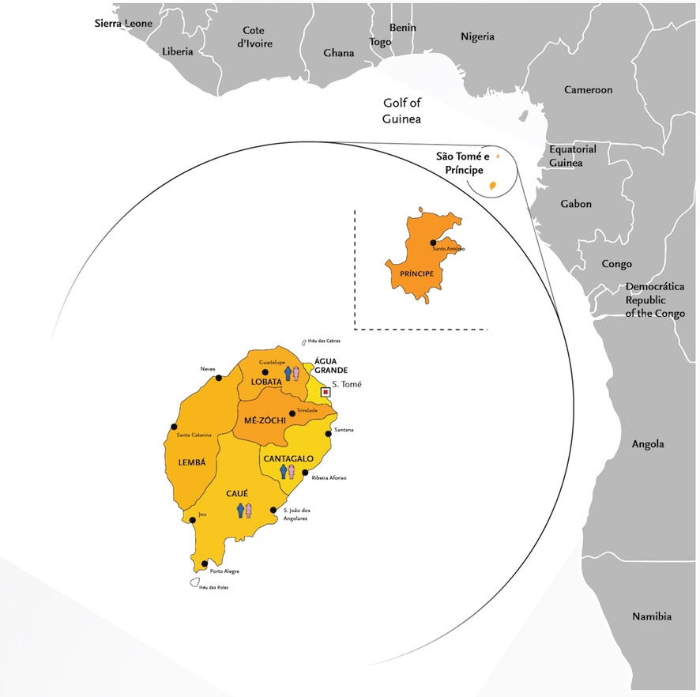

Figure 2. Percentage of students who have ever consumed alcohol or drugs.

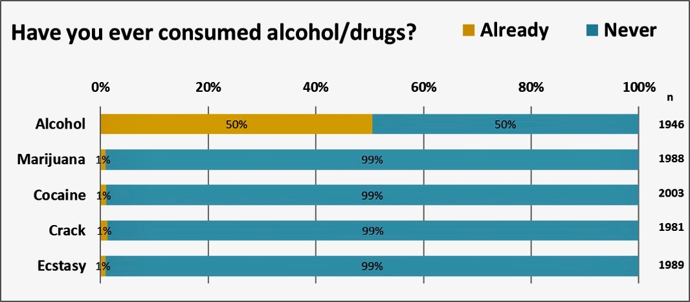

Figure 3. Alcohol consumption in the last 30 days

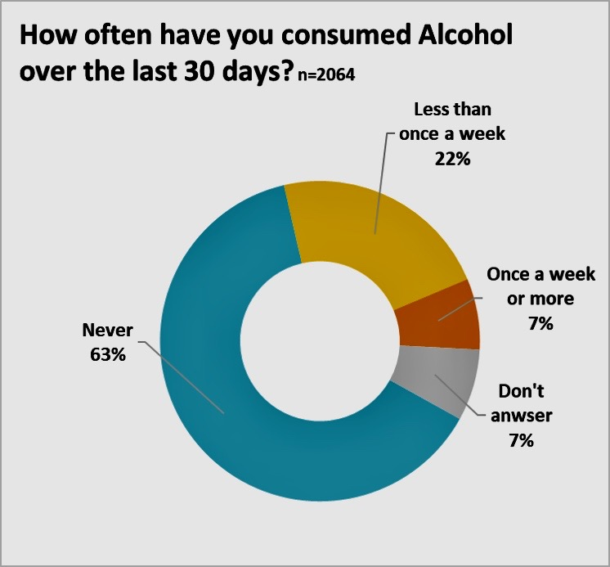

Figure 4. Characterization of alcohol consumption habits by demographic and social factors

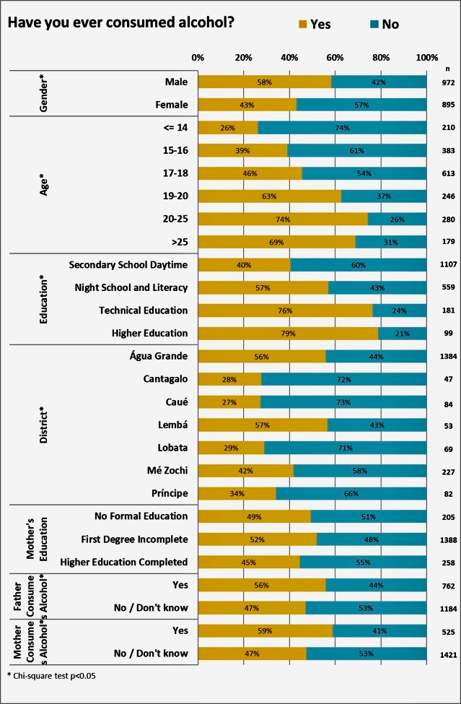

1. 1. Marmot M, Allen J. Health priorities and the social determinants of health. East Mediterr Heal J. 2015;21(9):671-672. doi:10.26719/2015.21.9.671

2. Francis Omaswa, editor Executive Director, African Centre for Global Health and Social Transformation (ACHEST) U. African Health Leaders: Making Change and Claiming the Future. Oxford Univ Press. 2015;1:2015. doi:10.1093/med/9780198703327.001.0001
Access on 07 July 2019

3. WHO. Global status report on alcohol and health. World Health Organization. 2014:1-100. ISBN 978-92-4-156563-9 https://www.who.int/substance_abuse/publications/global_alcohol_report/en/
Access on 07 July 2019

4. United Nations. Transforming our World: the 2030 Agenda for Sustainable Development. A/RES/70/1. https://sustainabledevelopment.un.org/content/documents/21252030%20Agenda%20for%20Sustainable%20Development%20web.pdf 2015 ; (September 2015).
Access on 07 July 2019

5. GBD 2017 Risk Factor Collaborators. Global, regional, and national comparative risk assessment of 84 behavioural, environmental and occupational, and metabolic risks or clusters of risks for 195 countries and territories, 1990–2017: a systematic analysis for the Global Burden of Disease Stu. Lancet. 2018 Nov 10;392(10159):1923-1994. doi: 10.1016/S0140-6736(18)32225-6. Epub 2018 Nov 8.
Access on 07 July 2019

6. World Health Organization. (‎2018)‎. World health statistics 2018: monitoring health for the SDGs, sustainable development goals. World Health Organization. https://apps.who.int/iris/handle/10665/272596.
Access on 07 July 2019

7. World Health Organization (WHO). SAO TOME AND PRINCIPE Factsheet of Health Statistics 2018. WHO African Heal Obs. 2018:0-21. http://www.aho.afro.who.int/profiles_information/images/c/cb/Sao_Tome_and_Principe-Statistical_Factsheet.pdf
Access on 07 July 2019

8. Analysis HS, Monitor AH. ATLAS of the African Health Statistics 2017. 2017:7-8. http://www.aho.afro.who.int/sites/default/files/Final for sharing_2.pdf (este documento é apenas um draft, é melhor usar e referir a versão defintiva)ANDRÉ CONSEGUE O LINK CORRECTO COM O DOCUMENTO?
Access on 17 July 2019

10. IJsselmuiden CB, Nchinda TC, Duale S, Tumwesigye NM, Serwadda D. Mapping Africa’s advanced public health education capacity: The AfriHealth project. Bull World Health Organ. 2007;85(12):914-922. doi:10.2471/BLT.07.045526

11. WHO. Sao Tome and Principe. WHO. 2010:2010. https://www.who.int/substance_abuse/publications/global_alcohol_report/profiles/stp.pdf
Access on 07 July 2019

12. World Health Organization (WHO). Global Status Report on noncommunicable diseases 2014. WHO. 2014:16. http://www.who.int/nmh/publications/ncd-status-report-2014/
Access on 07 July 2019

13. Roswall N, Weiderpass E. Alcohol as a risk factor for cancer: Existing evidence in a global perspective. J Prev Med Public Heal. 2015;48(1). doi:10.3961/jpmph.14.052
Access on 07 July 2019

14. WCRF. Diet, Nutrition, Physical Activity and Cancer: a Global Perspective: The Third Expert Report: Physical activity and the risk of cancer. WCRF/AICR. 2018:1-62. https://www.wcrf.org/sites/default/files/Physical-activity.pdf
15. Global T, Observatory C. (https://www.linkedin.com/groups/3713610/profile) " (http://www.iarc.fr/en/feeds/index.php) # (https://twitter.com/iarcwho). IARC. 2018. http://gco.iarc.fr.
Access on 07 July 2019

16. IARC Global Cancer Observatory. Sao Tome and Principe. IARC. 2019;16:2018-2019.
Access on 07 July 2019

17. A heavy burden: the productivity cost of illness in Africa. Brazzaville: WHO Regional Office for Africa; 2019. Licence: CC BY-NC-SA 3.0 IGO.
Access on 07 July 2019

18. Department of Health. UK Chief Medical Officers’ Alcohol Guidelines Review: Summary of the proposed new guidelines. 2015
Access on 07 July 2019

19. Clausen T, Rossow I, Naidoo N, Kowal P. Diverse alcohol drinking patterns in 20 African countries. Addiction. 2009 Jul;104(7):1147-54. doi:10.1111/j.1360-0443.2009.02559.x
Access on 07 July 2019

20. GBD 2017 SDG Collaborators. Measuring progress from 1990 to 2017 and projecting attainment to 2030 of the health-related Sustainable Development Goals for 195 countries and territories: a systematic analysis for the Global Burden of Disease Study 2017. Lancet. 2018 Nov 10;392(10159):2091-2138.doi:10.1016/S0140-6736(18)32281-5
Access on 07 July 2019

21. WHO. Mortality in Sao Tome and Principe. WHO. 2008:2008-2010. http://www.aho.afro.who.int/profiles_information/index.php/Sao_Tome_and_Principe:Mortality/pt.
Access on 07 July 2019

22. Wood AM, Kaptoge S, Butterworth AS, et al. Risk thresholds for alcohol consumption: combined analysis of individual-participant data for 599 912 current drinkers in 83 prospective studies. Lancet. 2018;391(10129):1513-1523. doi:10.1016/S0140-6736(18)30134-X
Access on 07 July 2019

23. Kanteres F, Rehm J, Lachenmeier DW. Artisanal alcohol production in Mayan Guatemala: Chemical safety evaluation with special regard to acetaldehyde contamination. Sci Total Environ. 2009;407(22):5861-5868. doi:10.1016/j.scitotenv.2009.08.012
Access on 07 July 2019

24. Lachenmeier DW. "Unrecorded and illicit alcohol". in Alcohol in the European Union. WHO Regional Office for Europe. 2012 pp. 29-34. doi:10.13140/RG.2.1.1146.0645
Access on 07 July 2019

25. Lachenmeier DW, Taylor BJ, Rehm J. Alcohol under the radar: Do we have policy options regarding unrecorded alcohol? Int J Drug Policy. 2011;22(2):153-160. doi:10.1016/j.drugpo.2010.11.002
Access on 07 July 2019

26. Múltiplos I. São Tomé e Príncipe Relatório Final. 2016.
Access on 07 July 2019

27. Marinho R. O álcool e os jovens. Rev Port Clin Geral. 2008;24:293-300

28. Barrio P, Reynolds J, García-Altés A, et al. Attitudes towards alcohol dependence and affected individuals: Persistence of negative stereotypes and illness beliefs between 1990 and 2011. Eur Addict Res. 2014;49(7):205-212.
doi: 10.1159/000362407.
Access on 07 July 2019

29. Rehm J, Anderson P, Barry J, et al. Prevalence of and potential influencing factors for alcohol dependence in Europe. Eur Addict Res. 2015;21(1). doi:10.1159/000365284
Access on 07 July 2019

30. Rehm JJ, Room R, Casswell S, et al. São Tomé et Principe Enquête STEPS Note de synthèse Sao Tomé et Principe Enquête STEPS Note de Synthèse. Lancet. 2009;92(1):18-19. doi:10.1097/ACM.0000000000001320
Access on 07 July 2019

31. Vieira PC, Aerts DRG de C, Freddo SL, Bittencourt A, Monteiro L. Uso de álcool, tabaco e outras drogas por adolescentes escolares em município do Sul do Brasil. Cad Saude Publica. 2008. doi:10.1590/S0102-311X2008001100004
Access on 07 July 2019

32. Malta DC, Mascarenhas MDM, Porto DL, et al. Prevalência do consumo de álcool e drogas entre adolescentes: análise dos dados da Pesquisa Nacional de Saúde Escolar. Rev Bras Epidemiol. 2011. doi:10.1590/S1415-790X2011000500014
Access on 07 July 2019

33. Ray R, Anish PK. Global strategy to reduce the harmful use of alcohol. Indian J Med Res. 2012;135(2):261. doi:10.1093/alcalc/agr035
Access on 07 July 2019

34. Glasgow RE, Vogt TM, Boles SM. Evaluating the public health impact of health promotion interventions: The RE-AIM framework. Am J Public Health. 1999. doi:10.2105/AJPH.89.9.1322
Access on 07 July 2019

35. Castells M. Communication, Power and Counter-power in the Network Society. Int J Commun. 2007. doi:10.1177/0094306111425016k (trata-se de uma recensão à obra, não da obra propriamente dita) André TENHO A OBRA. É MELHOR POR A VERSÃO CORRECTA?

36. Fawcett S. Building Multisectoral Partnerships for Population Health and Health Equity. Prev Chronic Dis. 2010.

37. Patel V, Flisher AJ, Hetrick S, McGorry P. Mental health of young people: a global public-health challenge. Lancet. 2007. doi:10.1016/S0140-6736(07)60368-7
Access on 07 July 2019

38. Labonte R, Laverack G. Capacity building in health promotion, part 1: For whom? And for what purpose? Crit Public Health. 2001. doi:10.1080/09581590110039838
Access on 07 July 2019

39. Fotheringham MJ1, Owies D, Leslie E, Owen N. Interactive health communication in preventive medicine: internet-based strategies in teaching and research. Am J Prev Med. 2000 Aug;19(2):113-20.
Access on 07 July 2019

40. Ezeh AC, Izugbara CO, Kabiru CW, et al. Building capacity for public and population health research in Africa: The consortium for advanced research training in Africa (CARTA) model. Glob Health Action. 2010;3(1). doi:10.3402/gha.v3i0.5693
Access on 07 July 2019

41. Kondilis BK, Kiriaze IJ, Athanasoulia AP, et al. Why health communication is important in public health. Rev Port Saúde Pública. 2009;19(1):41-64. doi:10.2471/BLT.08.056713
Access on 07 July 2019

42. Grindstaff L. Communication, Power and Counter-power in the Network Society. Int J Commun. 2007. doi:10.1177/0094306111425016k
Access on 07 July 2019

43. Behrendt S, Bühringer G, Perkonigg A, Lieb R, Beesdo-Baum K. Characteristics of developmentally early alcohol use disorder symptom reports: A prospective-longitudinal community study. Drug Alcohol Depend. 2013;131(3):308-315. doi:10.1016/j.drugalcdep.2012.12.024
Access on 07 July 2019

44. Angell M. The Ethics of Clinical Research in the Third World. N Engl J Med. 1997. doi:10.1056/NEJM199709183371209
Access on 07 July 2019

45. Barry M. Ethical Considerations of Human Investigation in Developing Countries. N Engl J Med. 1988. doi:10.1056/NEJM198810203191609

46. Hingson RW, Heeren T, Winter MR. Age at Drinking Onset and Alcohol Dependence. Arch Pediatr Adolesc Med. 2006;160(7):739. doi:10.1001/archpedi.160.7.739

47. Vieira DL, Ribeiro M, Romano M, Laranjeira RR. Álcool e adolescentes: Estudo para implementar polit́icas municipais. Rev Saude Publica. 2007. doi:10.1590/S0034-89102006005000022
Access on 07 July 2019

48. Pedrosa AA da S, Camacho LAB, Passos SRL, Oliveira R de VC de. Consumo de álcool entre estudantes universitários. Cad Saude Publica. 2011. doi:10.1590/S0102-311X2011000800016
Access on 07 July 2019

49. National Institute of Statistics. Sao Tome and Principe Multiple Indicator Cluster Survey 2014. 2016:448.
Access on 07 July 2019

50. Note S. São Tomé et Principe Enquête STEPS Note de synthèse Sao Tomé et Principe Enquête STEPS Note de Synthèse. 2008:18-19.
Access on 07 July 2019

51. WHO. Global Information System on Alcohol and Health (GISAH). 2012;Indicator(Printed 10/14/2014 9:54:58 AM):122. https://www.who.int/substance_abuse/activities/gisah_indicatorbook.pdf?ua=1.
Access on 07 July 2019

52. Roswall N, Weiderpass E. Alcohol as a risk factor for cancer: Existing evidence in a global perspective. J Prev Med Public Heal. 2015. doi:10.3961/jpmph.14.052
Access on 07 July 2019

53. Promoting Health Literacy to Encourage Prevention and Wellness.; 2015. doi:10.17226/13186
Access on 07 July 2019

54. Working on Health Communication. 2011. doi:10.4135/9781446251515
Access on 07 July 2019

55. Antonovsky A. The salutogenic model as a theory to guide health promotion. Health Promot Int. 1996;11(1):11-18. doi:10.1093/heapro/11.1.11
Access on 07 July 2019

56. Harter LM, Ellingson LL, Yamasaki J, Hook C, Walker T. Defining Moments…Telling Stories to Foster Well-being, Humanize Healthcare, and Advocate for Change. Health Commun. 2018;00(00):1-6. doi:10.1080/10410236.2018.1557468
Access on 07 July 2019

57. Rimal R. Why health communication is important in public health. Bull World Health Organ. 2009;87(4):247-247. doi:10.2471/BLT.08.056713
Access on 07 July 2019

58. Nutbeam DON. Health literacy as a public health goal: a challenge for contemporary health education and communication strategies into the 21st century CONTEMPORARY HEALTH. 2006;15(3):259-268.

59. Inchley J, Currie D, Vieno A, et al. Adolescent alcohol-related behaviours: trends and inequalities in the WHO European Region, 2002-2014. 2018:94. http://www.euro.who.int/en/publications/abstracts/adolescent-alcohol-related-behaviours-trends-and-inequalities-in-the-who-european-region,-20022014-2018.
Access on 07 July 2019

60. Mabry PL, Olster DH, Morgan GD, Abrams DB. Interdisciplinarity and Systems Science to Improve Population Health. A View from the NIH Office of Behavioral and Social Sciences Research. Am J Prev Med. 2008;35(2 SUPPL.). doi:10.1016/j.amepre.2008.05.018
Access on 07 July 2019

61. Pinheiro A, Picanço P, Barbeito J. A realidade do consumo de drogas nas populações escolares. Rev Port Clínica Geral. 2018;27(4):348-355. doi:10.32385/rpmgf.v27i4.10869
Access on 07 July 2019

62. Hofman K, Blomstedt Y, Addei S, et al. Addressing research capacity for health equity and the social determinants of health in three African countries: The INTREC programme. Glob Health Action. 2013;6(1). doi:10.3402/gha.v6i0.19668
Access on 07 July 2019

Figures Captions

Figure 1. Percentage of respondents admitting to having ever tried alcohol or illicit drugs.

Figure 2. Frequency of drinking in the last 30 days

Figure 3. Map of Sao Tome and Principe, highlighted on the African Coast, Gulf of Guinea, to allow identification of the provinces included in the present study (see Figure 4).

Figure 4. Determinants of alcohol consumption among the school population in São Tomé e Príncipe.

Frequency of drinking in the last 30 days

Figure 1

Alcohol consumption in the last 30 days

Figure 2

Map of Sao Tome and Principe, highlighted on the African Coast, Gulf of Guinea, to allow identification of the provinces included in the present study (see Figure 4)

Figure 3

Percentage of respondents admitting to having ever tried alcohol or illicit drugs

Figure 4
Tables Captions

Table 1. Chi square: Have you ever consumed alcohol?

Have you ever consumed alcohol?

Factor |  | YES | NO | p-value
Gender | Male | 566 | 406 | 7×10⁻¹¹
 | Female | 385 | 510
Age | <=14 | 55 | 155 | 2×10⁻³⁶
 | 15-16 | 150 | 233
 | 17-18 | 279 | 334
 | 19-20 | 154 | 92
 | 20-25 | 208 | 72
 | >25 | 123 | 56
Education | Secondary school daytime | 448 | 659 | 1×10⁻²⁸
 | Night school and literacy | 318 | 241
 | Technical education | 138 | 43
 | Higher education | 78 | 21
District | Água Grande | 773 | 611 | 1×10⁻¹³
 | Cantagalo | 13 | 34
 | Caué | 23 | 61
 | Lembá | 30 | 23
 | Lobata | 20 | 49
 | Mé Zochi | 95 | 132
 | Príncipe | 28 | 54
Mother’s education | No formal education | 101 | 104 | 0.091
 | First degree incomplete | 720 | 668
 | Higher education completed | 115 | 143
Father consumes | Yes | 425 | 337 | 0.0002
 | No / Don’t know | 557 | 627
Mother consumes | Yes | 309 | 216 | 9×10⁻⁶
 | No / Don’t know | 673 | 748

Table 1.

